Sunday | Monday | Tuesday | Wednesday |  | Thursday | Friday | Saturday
 | 1  Labor Day | 2 |  | 3 | 4 | 5 | 6
7  Grandparents Day | 8 | 9 |  | 10 | 11 | 12 | 13
14 | 15 | 16 |  | 17 | 18 | 19 | 20  Oktoberfest Begins
21 | 22  Rosh Hashanah  Autumn Begins | 23 |  | 24 | 25 | 26 | 27
28 | 29 | 30

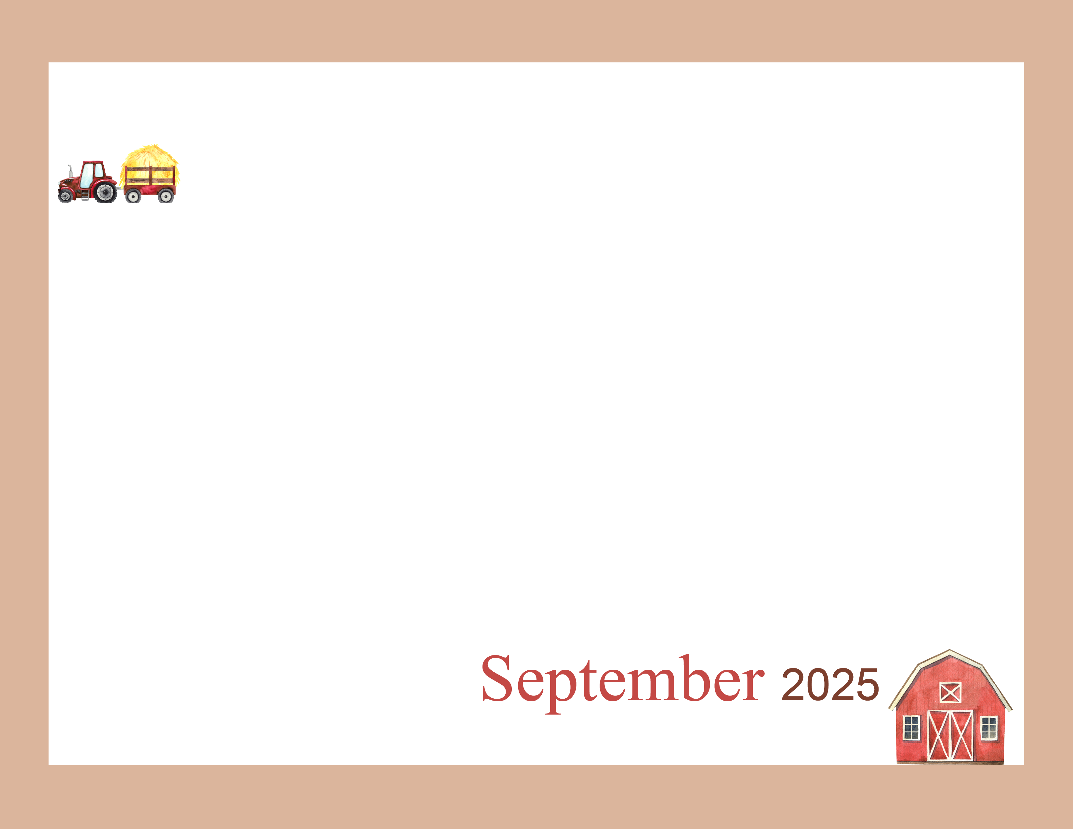  Happy Fall Y’all! | 9:45 Daily Chronicles  10:15 Fun with Fitness Ch 98.4  2:00 Patio Pals (Patio)  with Ice Pops  Happy Labor Day!! | 9:45 Daily Chronicles  10:15 Fun with Fitness Ch 98.4  2:00 Bingo (Aud)  6:45 Cup Pong (AC) | 9:45 Daily Chronicles  10:15 Fun with Fitness Ch 98.4  2:00 Rosary with the Legion of Mary (Aud)  6:45 Game Night (AC) | 9:45 Daily Chronicles  10:15 Fun with Fitness Ch 98.4  2:00 Independent Puzzles  6:45 Bingo Night (AC) | 9:45 Daily Chronicles  10:00 Communion (H)  10:15 Fun with Fitness Ch 98.4  2:00 Bible Study (Aud)  6:45 Happy Hour(AC) | 9:45 Daily Chronicles  10:15 Fun with Fitness Ch 98.4  2:00 Bingo (H)  Auditorium
9:45 Daily Chronicles  10:15 Fun with Fitness Ch 98.4  2:00 Worship (H)  Auditorium | 9:45 Daily Chronicles  10:15 Fun with Fitness Ch 98.4  2:00 Jewelry Making (AC)  6:45 Fun & Games (AC) | 9:45 Daily Chronicles  10:15 Fun with Fitness Ch 98.4  2:00 Bingo (Aud)  6:45 Hand Massage (AC) | 9:45 Daily Chronicles  10:15 Fun with Fitness Ch 98.4  2:00 Painting Fun (AC)  6:45 Game Night (AC) | 9:45 Daily Chronicles  10:15 Fun with Fitness Ch 98.4  2:00 Patio Pals (Patio)  6:45 Bingo Night (AC) | 9:45 Daily Chronicles  10:15 Fun with Fitness Ch 98.4  2:00 Bible Study (Aud)  6:45 Happy Hour(AC) | 9:45 Daily Chronicles  10:15 Fun with Fitness Ch 98.4  2:00 Bingo (H)  Auditorium
9:45 Daily Chronicles  10:15 Fun with Fitness Ch 98.4  2:00 Worship (H)  Auditorium | 9:45 Daily Chronicles  10:15 Fun with Fitness Ch 98.4  2:00 Mobile Museum (Aud)  6:45 Fun & Games (AC) | 9:45 Daily Chronicles  10:15 Fun with Fitness Ch 98.4  2:00 Bingo (Aud)  6:45 Patio Pals (Patio) | 9:45 Daily Chronicles  10:15 Fun with Fitness Ch 98.4  2:00 Bible study (Aud)  6:45 Game Night (AC) | 9:45 Daily Chronicles  10:15 Fun with Fitness Ch 98.4  2:00 Birthday Party (Aud)  6:45 Bingo Night (AC) | 9:45 Daily Chronicles  10:15 Fun with Fitness Ch 98.4  2:00 Catholic Mass (Aud)  6:45 Happy Hour(AC) | 9:45 Daily Chronicles  10:15 Fun with Fitness Ch 98.4  2:00 Bingo (H)  Auditorium
9:45 Daily Chronicles  10:15 Fun with Fitness Ch 98.4  2:00 Worship (H)  Auditorium | 9:45 Daily Chronicles  10:15 Fun with Fitness Ch 98.4  2:00 Getting Crafty (AC)  6:45 Fun & Games (AC) | 9:45 Daily Chronicles  10:15 Fun with Fitness Ch 98.4  2:00 Bingo (Aud)  6:45 Hand Massage (AC) | 9:45 Daily Chronicles  10:15 Fun with Fitness Ch 98.4  2:00 Pokeno (AC)  6:45 Game Night (AC) | 9:45 Daily Chronicles  10:15 Fun with Fitness Ch 98.4  2:00 Bible Study (Aud)  6:45 Bingo Night (AC) | 9:45 Daily Chronicles  10:15 Fun with Fitness Ch 98.4  2:00 Talent Show (Aud)  6:45 Happy Hour(AC) | 9:45 Daily Chronicles  10:15 Fun with Fitness Ch 98.4  2:00 Bingo (H)  Auditorium
9:45 Daily Chronicles  10:15 Fun with Fitness Ch 98.4  2:00 Worship (H)  Auditorium | 9:45 Daily Chronicles  10:15 Fun with Fitness Ch 98.4  2:00 Chef’s Corner (AC)  6:45 Fun & Games (AC) | 9:45 Daily Chronicles  10:15 Fun with Fitness Ch 98.4  2:00 Bingo (Aud)  6:45 Patio Pals (Patio) | Rosewood Gardens  D-Wing Recreation Calendar
Key D D-Neighborhood, AC-Activity Center, AUD-Auditorium, H-House Activity. Activities and locations are subject to change.

