Sunday | Monday | Tuesday | Wednesday |  | Thursday | Friday | Saturday
 | 1  Labor Day | 2 |  | 3 | 4 | 5 | 6
7  Grandparents Day | 8 | 9 |  | 10 | 11 | 12 | 13
14 | 15 | 16 |  | 17 | 18 | 19 | 20  Oktoberfest Begins
21 | 22  Rosh Hashanah  Autumn Begins | 23 |  | 24 | 25 | 26 | 27
28 | 29 | 30

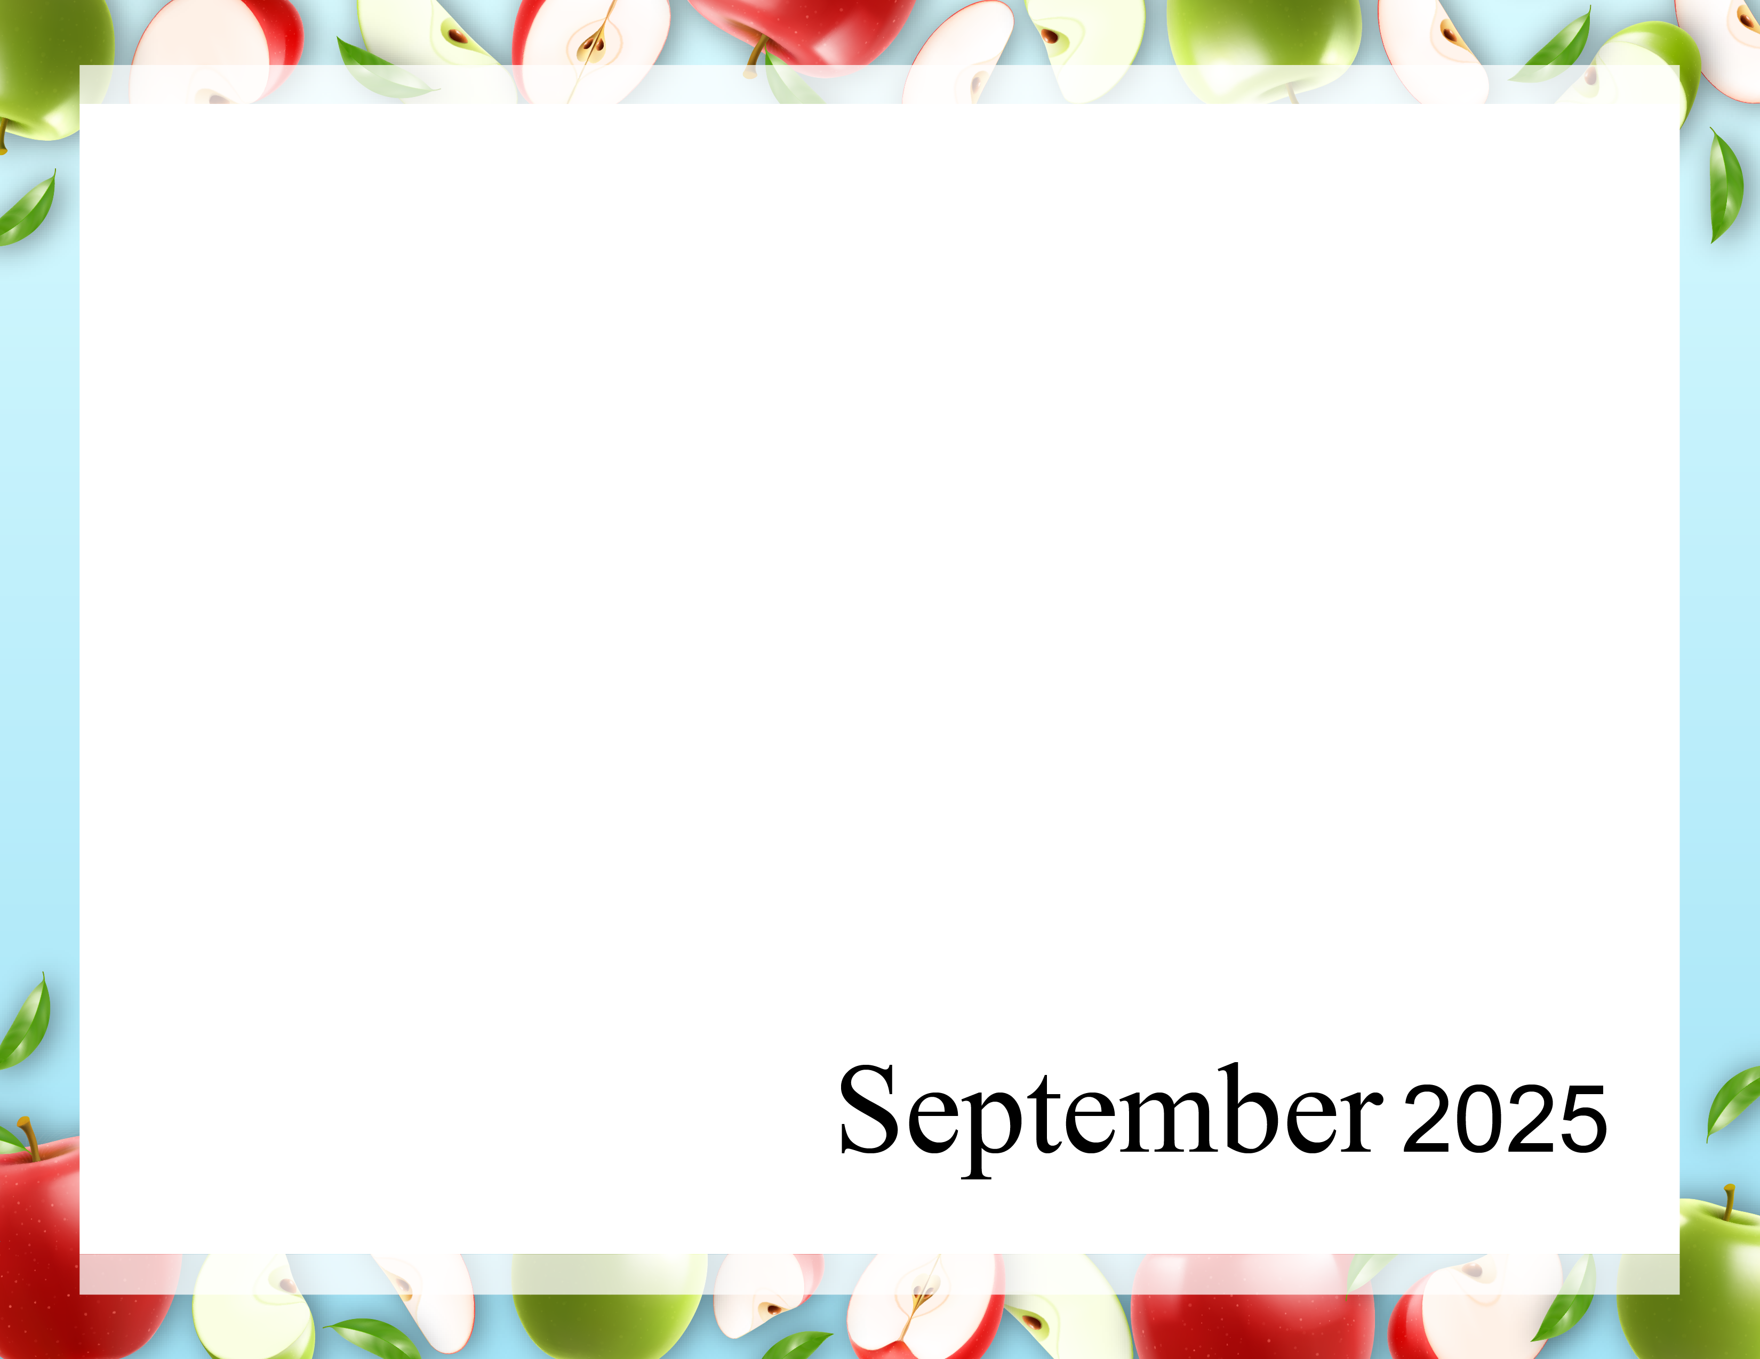  Happy  Fall  Y’all ! | 9:40 Daily Chronicle (H)  10:15 Fun with Fitness E  10:30 Music Trivia E  11:15 Fun with Fitness A  11:30 Music Trivia A  2:00 Patio Pals (Patio)  with Ice Pops | 9:40 Daily Chronicle (H)  10:15 Fun with Fitness E  10:30 Word Game E  11:15 Fun with Fitness A  11:30 Word Game A  2:00 Bingo (Aud)  6:30 Cup Pong (AC) | 9:40 Daily Chronicle (H)  10:15 Fun with Fitness E  10:30 Monthly Gazette E  11:15 Fun with Fitness A  11:30 Monthly Gazette A  2:00 Rosary with the  Legion of Mary (Aud)  6:45 Game Night (AC) | 9:40 Daily Chronicle (H)  10:15 Fun with Fitness E  10:30 Finish Lines E  11:15 Fun with Fitness A  11:30 Trivia A  2:00 Resident Council (Aud)  6:45 Bingo Night (AC) | 9:40 Daily Chronicle (H)  10:00 Communion (H)  10:15 Fun with Fitness E  10:30 Famous Couples  11:15 Fun with Fitness A  11:30 September IQ A  2:00 Bible Study (Aud)  6:45 Happy Hour (AC) | 9:40 Daily Chronicle (H)  10:15 Fun with Fitness E  10:30 Current Events E  11:15 Fun with Fitness A  11:30 Current Events A  2:00 Bingo (Aud)
9:40 Daily Chronicle (H)  10:15 Fun with Fitness E  10:30 Trivia Treasury E  11:15 Fun with Fitness A  11:30 Trivia Treasury A  2:00 Worship (Aud) | 9:40 Daily Chronicle (H)  10:15 Fun with Fitness E  10:30 Music Trivia E  11:15 Fun with Fitness A  11:30 Music Trivia A  2:00 Jewelry Making (AC)  6:45 Fun and Games (AC) | 9:40 Daily Chronicle (H)  10:15 Fun with Fitness E  10:30 Word Game E  11:15 Fun with Fitness A  11:30 Word Game A  2:00 Bingo (Aud)  6:30 Hand Massage (AC) | 9:40 Daily Chronicle (H)  10:15 Fun with Fitness E  10:30 ABC Game E  11:15 Fun with Fitness A  11:30 Finish Lines A  2:00 Painting Fun (AC)  6:45 Game Night (AC) | 9:40 Daily Chronicle (H)  10:15 Fun with Fitness E  10:30 Finish Lines E  11:15 Fun with Fitness A  11:30 Trivia A  2:00 Patio Pals (Patio)  6:45 Bingo Night (AC) | 9:40 Daily Chronicle (H)  10:15 Fun with Fitness E  10:30 Word Scramble E  11:15 Fun with Fitness A  11:30 Name that Tune A  2:00 Bible Study (Aud)  6:45 Happy Hour (AC) | 9:40 Daily Chronicle (H)  10:15 Fun with Fitness E  10:30 Current Events E  11:15 Fun with Fitness A  11:30 Current Events A  2:00 Bingo (Aud)
9:40 Daily Chronicle (H)  10:15 Fun with Fitness E  10:30 Trivia Treasury E  11:15 Fun with Fitness A  11:30 Trivia Treasury A  2:00 Worship (Aud) | 9:40 Daily Chronicle (H)  10:15 Fun with Fitness E  10:30 Music Trivia E  11:15 Fun with Fitness A  11:30 Music Trivia A  2:00 Mobile Museum (Aud)  6:45 Fun and Games (AC) | 9:40 Daily Chronicle (H)  10:15 Fun with Fitness E  10:30 Word Game E  11:15 Fun with Fitness A  11:30 Word Game A  2:00 Bingo (Aud)  6:30 Patio Pals (Patio) | 9:40 Daily Chronicle (H)  10:15 Fun with Fitness E  10:30 Famous Faces  11:15 Fun with Fitness A  11:30 Trivia A  2:00 Bible Study (Aud)  6:45 Game Night (AC) | 9:40 Daily Chronicle (H)  10:15 Fun with Fitness E  10:30 Finish Lines E  11:15 Fun with Fitness A  11:30 Finish the phrase A  2:00 Birthday Party(Aud)  6:45 Bingo Night (AC) | 9:40 Daily Chronicle (H)  10:00 Fun with Fitness E  10:30 Famous Couples E  11:15 Fun with Fitness A  11:30 Name that Tune A  2:00 Catholic Mass (Aud)  6:45 Happy Hour (AC) | 9:40 Daily Chronicle (H)  10:15 Fun with Fitness E  10:30 Current Events E  11:15 Fun with Fitness A  11:30 Current Events A  2:00 Bingo (Aud)
9:40 Daily Chronicle (H)  10:15 Fun with Fitness E  10:30 Trivia Treasury E  11:15 Fun with Fitness A  11:30 Trivia Treasury A  2:00 Worship (Aud) | 9:40 Daily Chronicle (H)  10:15 Fun with Fitness E  10:30 Music Trivia E  11:15 Fun with Fitness A  11:30 Music Trivia A  2:00 Getting Crafty (AC)  6:45 Fun and Games (AC) | 9:40 Daily Chronicle (H)  10:15 Fun with Fitness E  10:30 Word Game E  11:15 Fun with Fitness A  11:30 Word Game A  2:00 Bingo (Aud)  6:30 Hand Massage (AC) | 9:40 Daily Chronicle (H)  10:15 Fun with Fitness E  10:30 True or False E  11:15 Fun with Fitness A  11:30 True or False A  2:00 Pokeno (AC)  6:45 Game Night (AC) | 9:40 Daily Chronicle (H)  10:15 Fun with Fitness E  10:30 Finish Lines E  11:15 Fun with Fitness A  11:30 Trivia A  2:00 Bible Study (Aud)  6:45 Bingo Night (AC) | 9:40 Daily Chronicle (H)  10:00 Fun with Fitness E  10:30 Word Scramble E  11:15 Fun with Fitness A  11:30 Name that Tune A  2:00 Talent Show (Aud)  6:45 Happy Hour (AC) | 9:40 Daily Chronicle (H)  10:15 Fun with Fitness E  10:30 Current Events E  11:15 Fun with Fitness A  11:30 Current Events A  2:00 Bingo (Aud)
9:40 Daily Chronicle (H)  10:15 Fun with Fitness E  10:30 Trivia Treasury E  11:15 Fun with Fitness A  11:30 Trivia Treasury A  2:00 Worship (Aud) | 9:40 Daily Chronicle (H)  10:15 Fun with Fitness E  10:30 Music Trivia E  11:15 Fun with Fitness A  11:30 Music Trivia A  2:00 Chefs Corner (AC)  6:45 Fun and Games (AC) | 9:40 Daily Chronicle (H)  10:15 Fun with Fitness E  10:30 Word Game E  11:15 Fun with Fitness A  11:30 Word Game A  2:00 Bingo (Aud)  6:30 Patio Pals (Patio) | Rosewood Gardens  A & E Recreation Calendar
Key A A-Neighborhood, E E-Neighborhood, AC-Activity Center, Aud-Auditorium, H-House Activity. Activity and locations are subject to change.

