Sunday | Monday | Tuesday | Wednesday | Thursday | Friday | Saturday
 |  |  |  |  | 1 | 2
3 | 4 | 5 | 6 | 7 | 8 | 9
10 | 11 | 12 | 13 | 14 | 15 | 16
17 | 18 | 19 | 20 | 21 | 22 | 23
24 | 25 | 26 | 27 | 28 | 29 | 30
31

Rosewood Gardens  Memory Care |  |  |  |  | 9:45 Daily Chronicles (H)  10:15 Catholic Communion  10;15 Fun with Fitness (B)  10:30 Music and Dance(B)  2:00 Nail Glamour (B)  3:00 Relax and Unwind (B) | 9:45 Daily Chronicles (H)  10;15 Fun with Fitness (B)  11:00 Basketball (B)  2:00 Bingo (B)  3:00 Stories and Snacks (B)
9:45 Daily Chronicles (H)  10;15 Kickball (B)  11:00 Discuss and Recall (B)  2:00 Hymn Sing (B)  3:00 Relax and Unwind (B) | 9:45 Daily Chronicles (H)  10;15 Fun with Fitness (B)  11:00 Word Scramble (B)  2:00 Movie Matinee (B)  3:00 Relax and Unwind (B) | 9:45 Daily Chronicles (H)  10;15 Fun with Fitness (B)  11:00 Balloon Toss (B)  2:00 Bingo (B)  3:00 Relax and Unwind (B) | 9:45 Daily Chronicles (H)  10;15 Fun with Fitness (B)  11:00 Volleyball (B)  2:00 Rosary with the Legion of Mary (Aud)  3:00 Relax and Unwind (B) | 9:45 Daily Chronicles (H)  10;15 Fun with Fitness (B)  11:00 Word Game (B)  2:00 Hymn Sing (B)  3:00 Relax and Unwind (B) | 9:45 Daily Chronicles (H)  10:30 Music and Dance(B)  11:00 Ring Toss (B)  2:00 Nail Glamour (B)  3:00 Relax and Unwind (B) | 9:45 Daily Chronicles (H)  10;15 Fun with Fitness (B)  11:00 Basketball (B)  2:00 Bingo (B)  3:00 Stories and Snacks (B)
9:45 Daily Chronicles (H)  10;15 Kickball (B)  11:00 Discuss and Recall (B)  2:00 Hymn Sing (B)  3:00 Relax and Unwind (B) | 9:45 Daily Chronicles (H)  10;15 Fun with Fitness (B)  11:00 Ball Toss (B)  2:00 Marker Art (B)  3:00 Relax and Unwind (B) | 9:45 Daily Chronicles (H)  10;15 Fun with Fitness (B)  11:00 Bean Bag Toss (B)  2:00 Bingo (B)  3:00 Relax and Unwind (B) | 9:45 Daily Chronicles (H)  10;15 Fun with Fitness (B)  11:00 ABC Game (B)  2:00 Music and Memories  with Bobby Darin (B)  3:00 Relax and Unwind (B) | 9:45 Daily Chronicles (H)  10;15 Fun with Fitness (B)  11:00 Word Game (B)  2:00 Patio Pals (Patio)  3:00 Relax and Unwind (B | 9:45 Daily Chronicles (H)  10:30 Music and Dance(B)  11:00 Volleyball (B)  2:00 Catholic Mass (B)  3:00 Relax and Unwind (B) | 9:45 Daily Chronicles (H)  10;15 Fun with Fitness (B)  11:00 Basketball (B)  2:00 Bingo (B)  3:00 Stories and Snacks (B)
9:45 Daily Chronicles (H)  10;15 Kickball (B)  11:00 Discuss and Recall (B)  2:00 Hymn Sing (B)  3:00 Relax and Unwind (B) | 9:45 Daily Chronicles (H)  10;15 Fun with Fitness (B)  11:00 Ring Toss (B)  2:00 Armchair Travel (B)  -Hawaii  3:00 Relax and Unwind (B) | 9:45 Daily Chronicles (H)  10;15 Fun with Fitness (B)  11:00 Ball Toss (B)  2:00 Bingo (B)  3:00 Relax and Unwind (B) | 9:45 Daily Chronicles (H)  10:15 Fun with Fitness (B)  11:00 Balloon Volley  2:00 Birthday Party (Aud)  3:00 Relax and Unwind (B) | 9:45 Daily Chronicles (H)  10;15 Fun with Fitness (B)  11:00 Word Game (B)  2:00 Hymn Sing (B)  3:00 Relax and Unwind (B) | 9:45 Daily Chronicles (H)  10:30 Music and Dance(B)  11:00 ABC Game (B)  2:00 Nail Glamour (B)  3:00 Relax and Unwind (B) | 9:45 Daily Chronicles (H)  10;15 Fun with Fitness (B)  11:00 Basketball (B)  2:00 Bingo (B)  3:00 Stories and Snacks (B)
9:45 Daily Chronicles (H)  10;15 Kickball (B)  11:00 Discuss and Recall (B)  2:00 Hymn Sing (B)  3:00 Relax and Unwind (B) | 9:45 Daily Chronicles (H)  10;15 Fun with Fitness (B)  11:00 Word Game (B)  2:00 Parachute Fun (B)  3:00 Relax and Unwind (B) | 9:45 Daily Chronicles (H)  10;15 Fun with Fitness (B)  11:00 Ball Toss (B)  2:00 Bingo (B)  3:00 Relax and Unwind (B) | 9:45 Daily Chronicles (H)  10;15 Fun with Fitness (B)  11:00 Word Scramble (B)  2:00 Patio Pals (Patio)  3:00 Relax and Unwind (B) | 9:45 Daily Chronicles (H)  10;15 Fun with Fitness (B)  11:00 ABC Game (B)  2:00 Hymn Sing (B)  3:00 Relax and Unwind (B) | 9:45 Daily Chronicles (H)  10:30 Music and Dance(B)  11:00 Bean Bag Toss (B)  2:00 Nail Glamour (B)  3:00 Relax and Unwind (B) | 9:45 Daily Chronicles (H)  10;15 Fun with Fitness (B)  11:00 Basketball (B)  2:00 Bingo (B)  3:00 Stories and Snacks (B)
9:45 Daily Chronicles (H)  10;15 Kickball (B)  11:00 Discuss and Recall (B)  2:00 Hymn Sing (B)  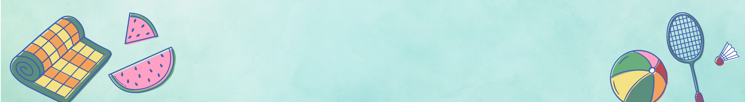  3:00 Relax and Unwind (B) | B - Wing Recreation Calendar
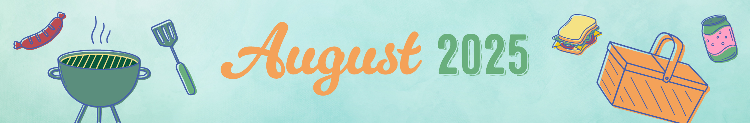
Key B B-Neighborhood, AC-Activity Center, Aud-Auditorium, H-House Activity. Activity and locations are subject to change.

