Sunday | Monday | Tuesday | Wednesday | Thursday | Friday | Saturday
 |  |  |  |  | 1 | 2
3 | 4 | 5 | 6 | 7 | 8 | 9
10 | 11 | 12 | 13 | 14 | 15 | 16
17 | 18 | 19 | 20 | 21 | 22 | 23
24 | 25 | 26 | 27 | 28 | 29 | 30
31

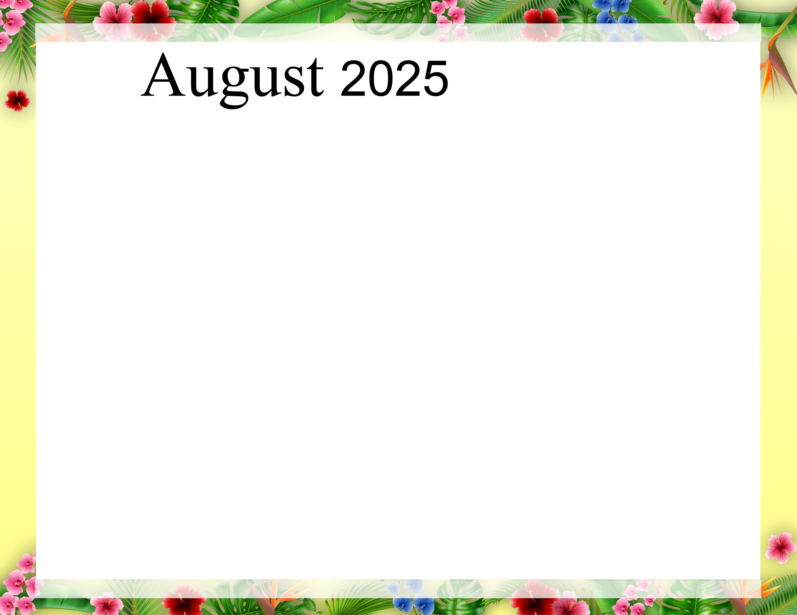  Rosewood Gardens - A & E Recreation Calendar |  |  |  |  | 9:40 Daily Chronicle (H)  10:00 Communion (H)  10:15 Fun with Fitness E  10:30 Famous Couples  11:15 Fun with Fitness A  11:30 August IQ A  2:00 Bible Study (Aud)  6:45 Happy Hour (AC) | 9:40 Daily Chronicle (H)  10:15 Fun with Fitness E  10:30 Current Events E  11:15 Fun with Fitness A  11:30 Current Events A  2:00 Bingo (Aud)
9:40 Daily Chronicle (H)  10:15 Fun with Fitness E  10:30 Trivia Treasury E  11:15 Fun with Fitness A  11:30 Trivia Treasury A  2:00 Worship (Aud) | 9:40 Daily Chronicle (H)  10:15 Fun with Fitness E  10:30 Music Trivia E  11:15 Fun with Fitness A  11:30 Music Trivia A  2:00 Crafts - Sand Art (AC)  6:45 Fun and Games | 9:40 Daily Chronicle (H)  10:15 Fun with Fitness E  10:30 Word Game E  11:15 Fun with Fitness A  11:30 Word Game A  2:00 Bingo (Aud)  6:30 Trivia (AC) | 9:40 Daily Chronicle (H)  10:15 Fun with Fitness E  10:30 Monthly Gazette E  11:15 Fun with Fitness A  11:30 Monthly Gazette A  2:00 Rosary with the  Legion of Mary (Aud)  6:45 Game Night (AC) | 9:40 Daily Chronicle (H)  10:15 Fun with Fitness E  10:30 Finish Lines E  11:15 Fun with Fitness A  11:30 Trivia A  2:00 Resident Council (Aud)  6:45 Bingo Night (AC) | 9:40 Daily Chronicle (H)  10:30 Famous Couples E  11:15 Fun with Fitness A  11:30 Name that Tune A  2:00 Bible Study (Aud)  6:45 Happy Hour (AC) | 9:40 Daily Chronicle (H)  10:15 Fun with Fitness E  10:30 Current Events E  11:15 Fun with Fitness A  11:30 Current Events A  2:00 Bingo (Aud)
9:40 Daily Chronicle (H)  10:15 Fun with Fitness E  10:30 Trivia Treasury E  11:15 Fun with Fitness A  11:30 Trivia Treasury A  2:00 Worship (Aud) | 9:40 Daily Chronicle (H)  10:15 Fun with Fitness E  10:30 Music Trivia E  11:15 Fun with Fitness A  11:30 Music Trivia A  2:00 Making Cone Bird Feeders (AC)  6:45 Fun and Games (AC) | 9:40 Daily Chronicle (H)  10:15 Fun with Fitness E  10:30 Word Game E  11:15 Fun with Fitness A  11:30 Word Game A  2:00 Bingo (Aud)  6:30 Hand Massage (AC) | 9:40 Daily Chronicle (H)  10:15 Fun with Fitness E  10:30 ABC Game E  11:15 Fun with Fitness A  11:30 Finish Lines A  2:00 Painting Fun (AC)  6:45 Game Night (AC) | 9:40 Daily Chronicle (H)  10:15 Fun with Fitness E  10:30 Finish Lines E  11:15 Fun with Fitness A  11:30 Trivia A  2:00 Beach Party (Aud)  6:45 Bingo Night (AC) | 9:40 Daily Chronicle (H)  10:00 Fun with Fitness E  10:30 Famous Couples E  11:15 Fun with Fitness A  11:30 Name that Tune A  2:00 Catholic Mass (Aud)  6:45 Happy Hour (AC) | 9:40 Daily Chronicle (H)  10:15 Fun with Fitness E  10:30 Current Events E  11:15 Fun with Fitness A  11:30 Current Events A  2:00 Bingo (Aud)
9:40 Daily Chronicle (H)  10:15 Fun with Fitness E  10:30 Trivia Treasury E  11:15 Fun with Fitness A  11:30 Trivia Treasury A  2:00 Worship (Aud) | 9:40 Daily Chronicle (H)  10:15 Fun with Fitness E  10:30 Music Trivia E  11:15 Fun with Fitness A  11:30 Music Trivia A  2:00 Sunflower Craft (AC)  6:45 Fun and Games (AC) | 9:40 Daily Chronicle (H)  10:15 Fun with Fitness E  10:30 Word Game E  11:15 Fun with Fitness A  11:30 Word Game A  2:00 Bingo (Aud)  6:30 Evening on the Patio (Patio) | 9:40 Daily Chronicle (H)  10:15 Fun with Fitness E  10:30 Famous Faces  11:15 Fun with Fitness A  11:30 Trivia A  2:00 Birthday Party with  DJ Neil (Aud)  6:45 Game Night (AC) | 9:40 Daily Chronicle (H)  10:15 Fun with Fitness E  10:30 Finish Lines E  11:15 Fun with Fitness A  11:30 Finish the phrase A  2:00 Ice Cream Social (Aud)  6:45 Bingo Night (AC) | 9:40 Daily Chronicle (H)  10:00 Fun with Fitness E  10:30 Word Scramble E  11:15 Fun with Fitness A  11:30 Name that Tune A  2:00 Bible Study (Aud)  6:45 Happy Hour (AC) | 9:40 Daily Chronicle (H)  10:15 Fun with Fitness E  10:30 Current Events E  11:15 Fun with Fitness A  11:30 Current Events A  2:00 Bingo (Aud)
9:40 Daily Chronicle (H)  10:15 Fun with Fitness E  10:30 Trivia Treasury E  11:15 Fun with Fitness A  11:30 Trivia Treasury A  2:00 Worship (Aud) | 9:40 Daily Chronicle (H)  10:15 Fun with Fitness E  10:30 Music Trivia E  11:15 Fun with Fitness A  11:30 Music Trivia A  2:00 Chefs Corner (AC)  6:45 Fun and Games (AC) | 9:40 Daily Chronicle (H)  10:15 Fun with Fitness E  10:30 Word Game E  11:15 Fun with Fitness A  11:30 Word Game A  2:00 Bingo (Aud)  6:30 Hand Massage (AC) | 9:40 Daily Chronicle (H)  10:15 Fun with Fitness E  10:30 True or False E  11:15 Fun with Fitness A  11:30 True or False A  2:00 Flower Arranging (AC)  6:45 Game Night (AC) | 9:40 Daily Chronicle (H)  10:15 Fun with Fitness E  10:30 Finish Lines E  11:15 Fun with Fitness A  11:30 Trivia A  2:00 Karaoke (Aud)  6:45 Bingo Night (AC) | 9:40 Daily Chronicle (H)  10:00 Fun with Fitness E  10:30 Word Scramble E  11:15 Fun with Fitness A  11:30 Name that Tune A  2:00 Bible Study (Aud)  6:45 Happy Hour (AC) | 9:40 Daily Chronicle (H)  10:15 Fun with Fitness E  10:30 Current Events E  11:15 Fun with Fitness A  11:30 Current Events A  2:00 Bingo (Aud)
9:40 Daily Chronicle (H)  10:15 Fun with Fitness E  10:30 Trivia Treasury E  11:15 Fun with Fitness A  11:30 Trivia Treasury A  2:00 Worship (Aud) | “August is the border between Summer and Autumn;  it is the most beautiful month I know.”  -the Pioneer Woman
Key A A-Neighborhood, E E-Neighborhood, AC-Activity Center, Aud-Auditorium, H-House activity. Activity and locations are subject to change.

