Sunday | Monday | Tuesday | Wednesday |  | Thursday | Friday | Saturday
 |  | 1  Canada Day |  | 2 | 3 | 4  Independence Day (US) | 5
6 | 7 | 8 |  | 9 | 10 | 11 | 12
13 | 14 | 15 |  | 16 | 17 | 18 | 19
20 | 21 | 22 |  | 23 | 24 | 25 | 26
27 | 28 | 29 |  | 30 | 31

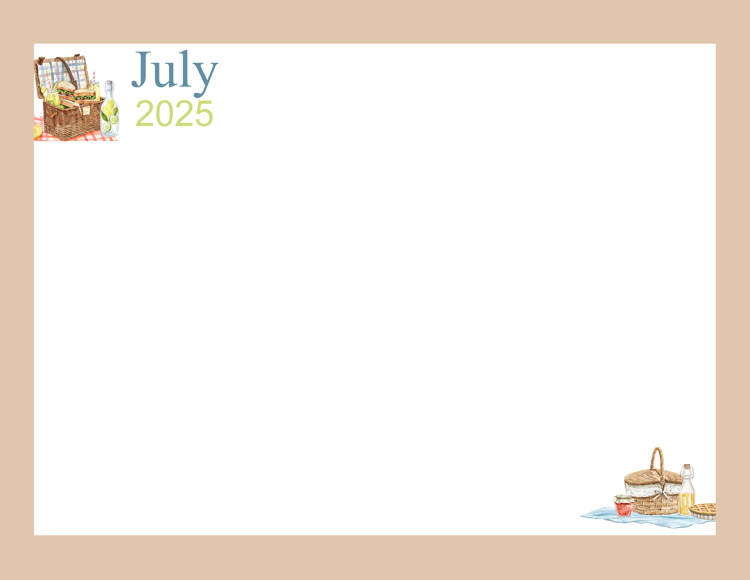 |  | 9:45 Daily Chronicles  10:15 Fun with Fitness Ch 98.4  2:00 Bingo (Aud)  6:45 Name 5 Game (AC) | 9:45 Daily Chronicles  10:15 Fun with Fitness Ch 98.4  2:00 Rosary with the Legion of Mary (Aud)  6:45 Game Night (AC) | 9:45 Daily Chronicles  10:15 Fun with Fitness Ch 98.4  Independent Puzzles  6:45 Bingo Night (AC) | 9:45 Daily Chronicles  10:15 Fun with Fitness Ch 98.4  2:00 Bible Study (Aud)  3:00 July 4th Social (Aud) | 9:45 Daily Chronicles  10:15 Fun with Fitness Ch 98.4  2:00 Bingo (H)  Auditorium
9:45 Daily Chronicles  10:15 Fun with Fitness Ch 98.4  2:00 Worship (H)  Auditorium | 9:45 Daily Chronicles  10:15 Fun with Fitness Ch 98.4  2:00 Crafts (AC)  6:45 Fun & Games (AC) | 9:45 Daily Chronicles  10:15 Fun with Fitness Ch 98.4  2:00 Bingo (Aud)  6:45 Hand Massage (AC) | 9:45 Daily Chronicles  10:15 Fun with Fitness Ch 98.4  2:00 Karaoke(Aud)  6:45 Game Night (AC) | 9:45 Daily Chronicles  10:15 Fun with Fitness Ch 98.4  2:00 Patio Pals (Patio)  6:45 Bingo Night (AC) | 9:45 Daily Chronicles  10:15 Fun with Fitness Ch 98.4  2:00 Bible Study(Aud)  6:45 Happy Hour (AC) | 9:45 Daily Chronicles  10:15 Fun with Fitness Ch 98.4  2:00 Bingo (H)  Auditorium
9:45 Daily Chronicles  10:15 Fun with Fitness Ch 98.4  2:00 Worship (H)  Auditorium | 9:45 Daily Chronicles  10:15 Fun with Fitness Ch 98.4  2:00 Jewelry Making (AC)  6:45 Fun & Games (AC) | 9:45 Daily Chronicles  10:15 Fun with Fitness Ch 98.4  2:00 Bingo (Aud)  6:45 Evening on the Patio (Patio) | 9:45 Daily Chronicles  10:15 Fun with Fitness Ch 98.4  2:00 Painting Fun (AC)  6:45 Game Night (AC) | 9:45 Daily Chronicles  10:15 Fun with Fitness Ch 98.4  2:00 Patio Pals (Patio)  6:45 Bingo Night (AC) | 9:45 Daily Chronicles  10:15 Fun with Fitness Ch 98.4  2:00 Catholic Mass(Aud)  6:45 Happy Hour (AC) | 9:45 Daily Chronicles  10:15 Fun with Fitness Ch 98.4  2:00 Bingo (H)  Auditorium
9:45 Daily Chronicles  10:15 Fun with Fitness Ch 98.4  2:00 Worship (H)  Auditorium | 9:45 Daily Chronicles  10:15 Fun with Fitness Ch 98.4  2:00 Crafts (AC)  6:45 Fun & Games (AC) | 9:45 Daily Chronicles  10:15 Fun with Fitness Ch 98.4  2:00 Bingo (Aud) | 9:45 Daily Chronicles  10:15 Fun with Fitness Ch 98.4  2:00 Birthday Party (Aud)  6:45 Game Night (AC) | 9:45 Daily Chronicles  10:15 Fun with Fitness Ch 98.4  2:00 Patio Pals (Patio)  6:45 Bingo Night (AC) | 9:45 Daily Chronicles  10:15 Fun with Fitness Ch 98.4  2:00 Bible Study(Aud)  6:45 Happy Hour (AC) | 9:45 Daily Chronicles  10:15 Fun with Fitness Ch 98.4  2:00 Bingo (H)  Auditorium
9:45 Daily Chronicles  10:15 Fun with Fitness Ch 98.4  2:00 Worship (H)  Auditorium | 9:45 Daily Chronicles  10:15 Fun with Fitness Ch 98.4  2:00 Chef’s Corner (AC)  6:45 Fun & Games (AC) | 9:45 Daily Chronicles  10:15 Fun with Fitness Ch 98.4  2:00 Bingo (Aud)  6:45 Hand Massage (AC) | 9:45 Daily Chronicles  10:15 Fun with Fitness Ch 98.4  2:00 Pokeno (AC)  6:45 Game Night (AC) | 9:45 Daily Chronicles  10:15 Fun with Fitness Ch 98.4  2:00 Patio Pals (Patio)  6:45 Game Night (AC) | D-Wing Recreation Calendar  Rosewood Gardens
Key D D-Neighborhood, AC-Activity Center, Aud-Auditorium, H-House Activity. Activities and locations are subject to change.

