Sunday | Monday | Tuesday | Wednesday |  | Thursday | Friday | Saturday
 |  | 1  Canada Day |  | 2 | 3 | 4  Independence Day (US) | 5
6 | 7 | 8 |  | 9 | 10 | 11 | 12
13 | 14 | 15 |  | 16 | 17 | 18 | 19
20 | 21 | 22 |  | 23 | 24 | 25 | 26
27 | 28 | 29 |  | 30 | 31

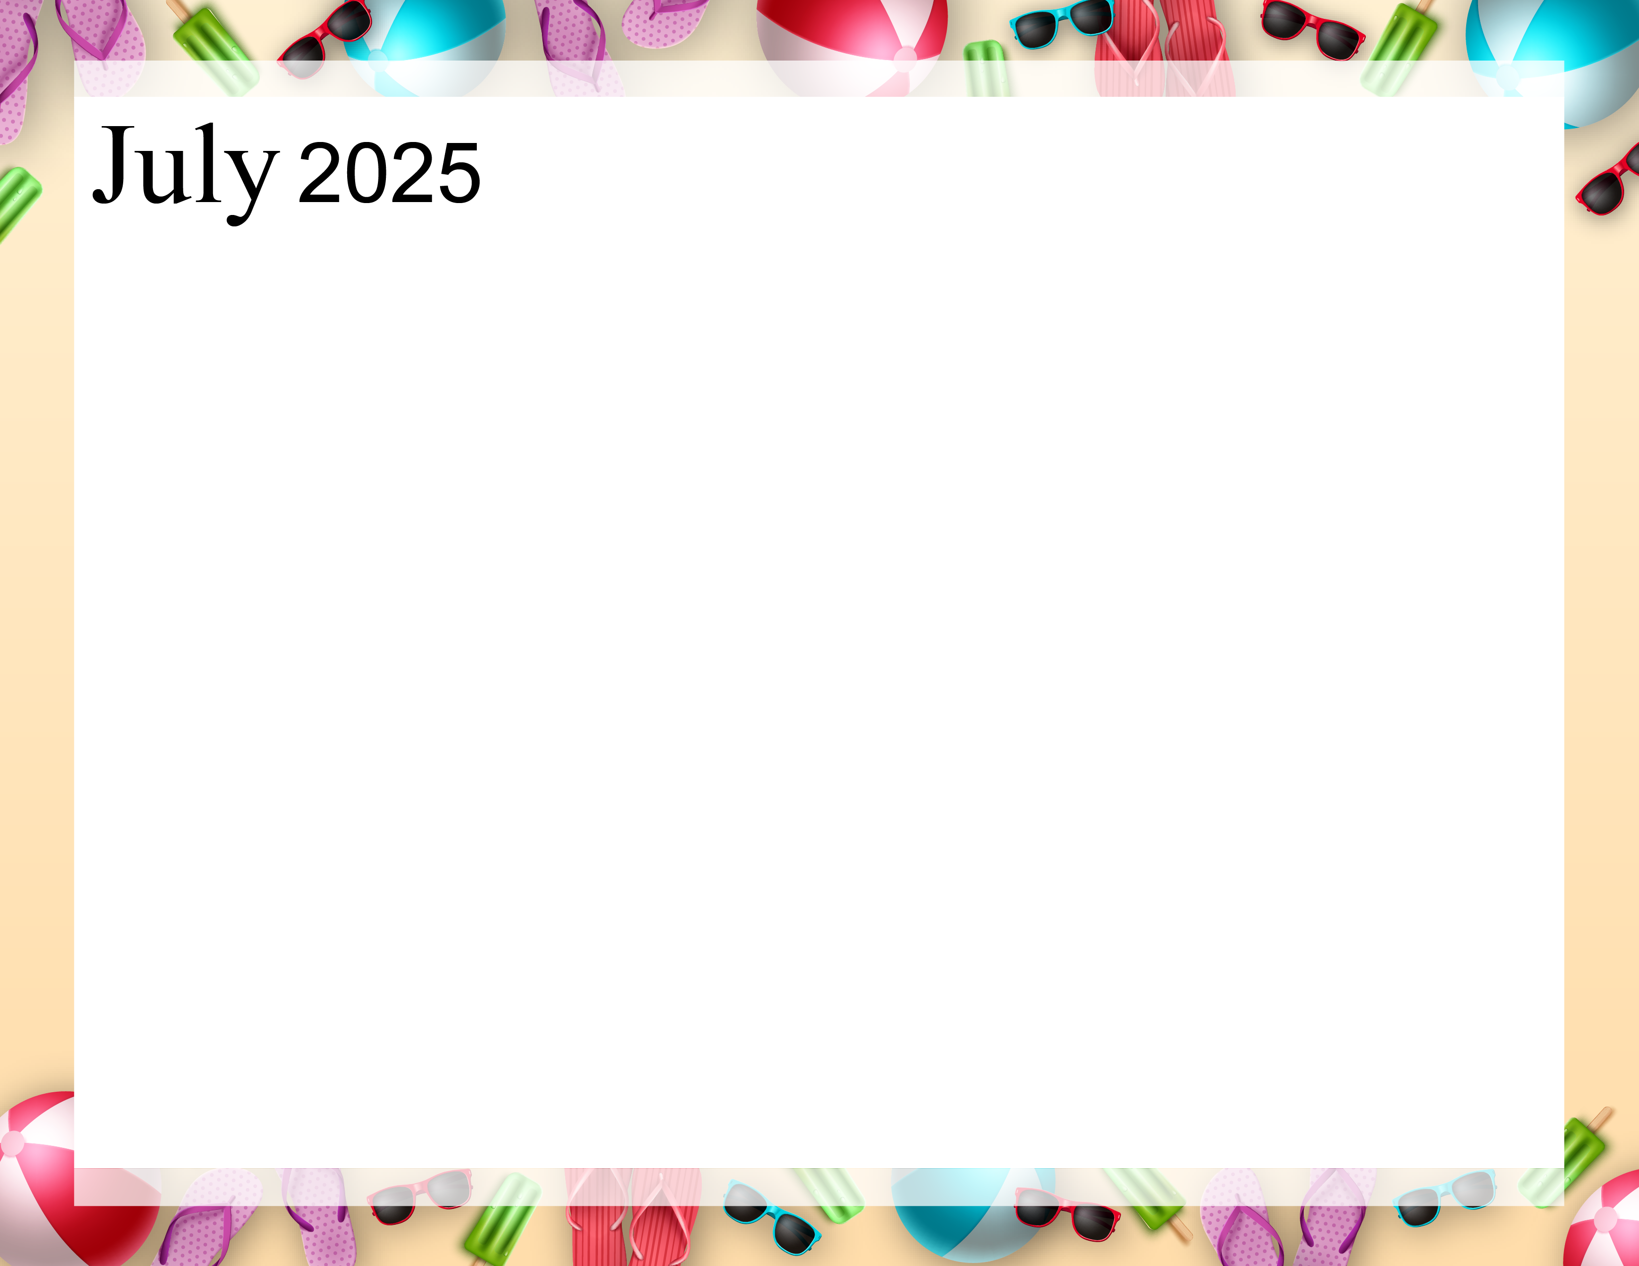  Rosewood Gardens  A & E Recreation Calendar |  | 9:40 Daily Chronicle (H)  10:15 Fun with Fitness E  10:30 Word Game E  11:15 Fun with Fitness A  11:30 Word Game A  2:00 Bingo (Aud)  6:30 Name 5 Game (AC) | 9:40 Daily Chronicle (H)  10:15 Fun with Fitness E  10:30 Monthly Gazette E  11:15 Fun with Fitness A  11:30 Monthly Gazette A  2:00 Rosary with the  Legion of Mary (Aud)  6:45 Game Night (AC) | 9:40 Daily Chronicle (H)  10:15 Fun with Fitness E  10:30 Finish Lines E  11:15 Fun with Fitness A  11:30 Trivia A  2:00 Resident Council (Aud)  6:45 Bingo Night (AC) | 9:40 Daily Chronicle (H)  10:15 Fun with Fitness E  10:30 Famous Couples E  11:15 Fun with Fitness A  11:30 July IQ A  2:00 Bible Study (Aud)  3:00 Fourth of July Social (Aud) | 9:40 Daily Chronicle (H)  10:15 Fun with Fitness E  10:30 Current Events E  11:15 Fun with Fitness A  11:30 Current Events A  2:00 Bingo (Aud)
9:40 Daily Chronicle (H)  10:15 Fun with Fitness E  10:30 Trivia Treasury E  11:15 Fun with Fitness A  11:30 Trivia Treasury A  2:00 Worship (Aud) | 9:40 Daily Chronicle (H)  10:15 Fun with Fitness E  10:30 Music Trivia E  11:15 Fun with Fitness A  11:30 Music Trivia A  2:00 Crafts (AC)  6:45 Fun and Games | 9:40 Daily Chronicle (H)  10:15 Fun with Fitness E  10:30 Word Game E  11:15 Fun with Fitness A  11:30 Word Game A  2:00 Bingo (Aud)  6:30 Hand Massage (AC) | 9:40 Daily Chronicle (H)  10:15 Fun with Fitness E  10:30 ABC Game E  11:15 Fun with Fitness A  11:30 Finish Lines A  2:00 Karaoke (Aud)  6:45 Game Night (AC) | 9:40 Daily Chronicle (H)  10:15 Fun with Fitness E  10:30 Finish Lines E  11:15 Fun with Fitness A  11:30 Trivia A  2:00 Patio Pals  6:45 Bingo Night (AC) | 9:40 Daily Chronicle (H)  10:00 Catholic Communion (H)  10:30 Famous Couples E  11:15 Fun with Fitness A  11:30  2:00 Bible Study (Aud)  6:45 Happy Hour (AC) | 9:40 Daily Chronicle (H)  10:15 Fun with Fitness E  10:30 Current Events E  11:15 Fun with Fitness A  11:30 Current Events A  2:00 Bingo (Aud)
9:40 Daily Chronicle (H)  10:15 Fun with Fitness E  10:30 Trivia Treasury E  11:15 Fun with Fitness A  11:30 Trivia Treasury A  2:00 Worship (Aud) | 9:40 Daily Chronicle (H)  10:15 Fun with Fitness E  10:30 Music Trivia E  11:15 Fun with Fitness A  11:30 Music Trivia A  2:00 Jewelry Making (AC)  6:45 Fun and Games (AC) | 9:40 Daily Chronicle (H)  10:15 Fun with Fitness E  10:30 Word Game E  11:15 Fun with Fitness A  11:30 Word Game A  2:00 Bingo (Aud)  6:30 Evening on the Patio (Patio) | 9:40 Daily Chronicle (H)  10:15 Fun with Fitness E  10:30 Famous Faces  11:15 Fun with Fitness A  11:30 Trivia A  2:00 Painting Fun (AC)  6:45 Game Night (AC) | 9:40 Daily Chronicle (H)  10:15 Fun with Fitness E  10:30 Finish Lines E  11:15 Fun with Fitness A  11:30 Trivia A  2:00 Patio Pals  6:45 Bingo Night (AC) | 9:40 Daily Chronicle (H)  10:00 Fun with Fitness E  10:30 Famous Couples E  11:15 Fun with Fitness A  11:30 Name that Tune A  2:00 Catholic Mass (Aud)  6:45 Happy Hour (AC) | 9:40 Daily Chronicle (H)  10:15 Fun with Fitness E  10:30 Current Events E  11:15 Fun with Fitness A  11:30 Current Events A  2:00 Bingo (Aud)
9:40 Daily Chronicle (H)  10:15 Fun with Fitness E  10:30 Trivia Treasury E  11:15 Fun with Fitness A  11:30 Trivia Treasury A  2:00 Worship (Aud) | 9:40 Daily Chronicle (H)  10:15 Fun with Fitness E  10:30 Music Trivia E  11:15 Fun with Fitness A  11:30 Music Trivia A  2:00 Crafts (AC)  6:45 Fun and Games (AC) | 9:40 Daily Chronicle (H)  10:15 Fun with Fitness E  10:30 Word Game E  11:15 Fun with Fitness A  11:30 Word Game A  2:00 Bingo (Aud) | 9:40 Daily Chronicle (H)  10:15 Fun with Fitness E  10:30 True or False E  11:15 Fun with Fitness A  11:30 True or False A  2:00 Birthday Party (Aud)  6:45 Game Night (AC) | 9:40 Daily Chronicle (H)  10:15 Fun with Fitness E  10:30 Finish Lines E  11:15 Fun with Fitness A  11:30 Trivia A  2:00 Patio Pals  6:45 Bingo Night (AC) | 9:40 Daily Chronicle (H)  10:00 Fun with Fitness E  10:30 Word Scramble E  11:15 Fun with Fitness A  11:30 Name that Tune A  2:00 Bible Study (Aud)  6:45 Happy Hour (AC) | 9:40 Daily Chronicle (H)  10:15 Fun with Fitness E  10:30 Current Events E  11:15 Fun with Fitness A  11:30 Current Events A  2:00 Bingo (Aud)
9:40 Daily Chronicle (H)  10:15 Fun with Fitness E  10:30 Trivia Treasury E  11:15 Fun with Fitness A  11:30 Trivia Treasury A  2:00 Worship (Aud) | 9:40 Daily Chronicle (H)  10:15 Fun with Fitness E  10:30 Music Trivia E  11:15 Fun with Fitness A  11:30 Music Trivia A  2:00 Chefs Corner (AC)  6:45 Fun and Games (AC | 9:40 Daily Chronicle (H)  10:15 Fun with Fitness E  10:30 Word Game E  11:15 Fun with Fitness A  11:30 Word Game A  2:00 Bingo (Aud)  6:30 Hand Massage (AC) | 9:40 Daily Chronicle (H)  10:15 Fun with Fitness E  10:30 True or False E  11:15 Fun with Fitness A  11:30 True or False A  2:00 Pokeno (AC)  6:45 Game Night (AC) | 9:40 Daily Chronicle (H)  10:15 Fun with Fitness E  10:30 Finish Lines E  11:15 Fun with Fitness A  11:30 Trivia A  2:00 Patio Pals  6:45 Bingo Night (AC) | “July is a Blind date with Summer”!  -Hal Boreland
Key A A-Neighborhood, E E-Neighborhood, AC-Activity Center, Aud-Auditorium, H-House Activity. Activity and locations are subject to change.

