Sunday | Monday | Tuesday | Wednesday |  | Thursday | Friday | Saturday
 |  |  |  |  | 1  May Day | 2 | 3
4 | 5  Cinco de Mayo | 6 |  | 7 | 8 | 9 | 10
11  Mother’s Day  National Skill Nursing Care Week | 12 | 13 |  | 14 | 15 | 16 | 17  Armed Forces Day
18 | 19  Victoria Day (Canada) | 20 |  | 21 | 22 | 23 | 24
25 | 26  Memorial Day | 27 |  | 28 | 29 | 30 | 31

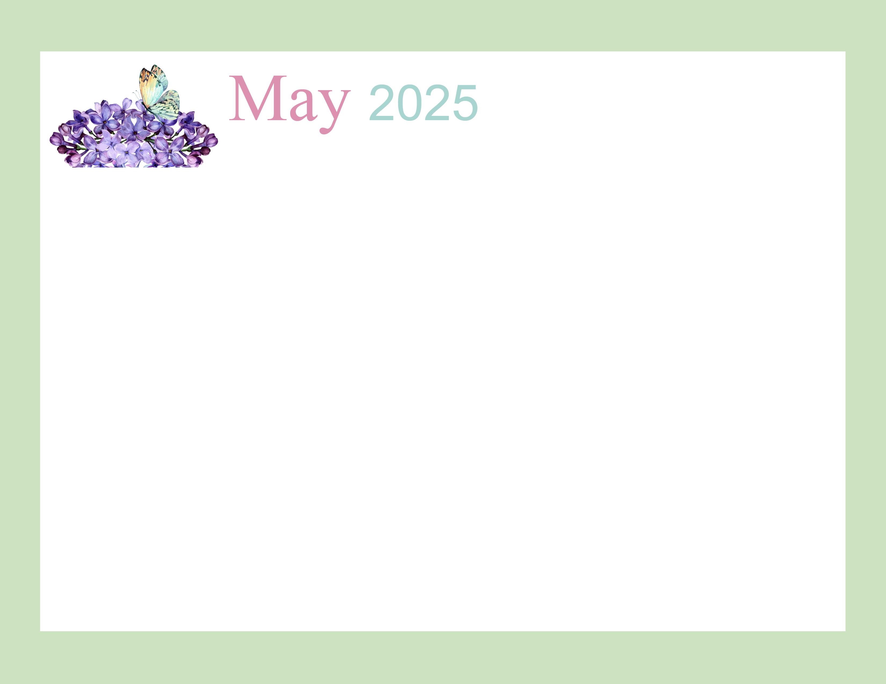  Rosewood Gardens  D-Wing Recreation Calendar |  |  |  | 9:45 Daily Chronicles  10:15 Fun with Fitness Ch 98.4  2:00 Patio Pals (Patio)  6:45 Bingo Night (AC) | 9:45 Daily Chronicles  10:00 Communion  10:15 Fun with Fitness Ch 98.4  2:00 Bible Study (Aud)  6:45 Happy Hour (AC) | 9:45 Daily Chronicles  10:15 Fun with Fitness Ch 98.4  2:00 Bingo (H)  Auditorium
9:45 Daily Chronicles  10:15 Fun with Fitness Ch 98.4  2:00 Worship (H)  Auditorium | 9:45 Daily Chronicles  10:15 Fun with Fitness Ch 98.4  2:00 Crafts (AC)  6:45 Fun & Games (AC) | 9:45 Daily Chronicles  10:15 Fun with Fitness Ch 98.4  2:00 Bingo (Aud)  6:45 Cup Pong (AC) | 9:45 Daily Chronicles  10:15 Fun with Fitness Ch 98.4  2:00 Rosary with the Legion of Mary (Aud)  6:45 Game Night (AC) | 9:45 Daily Chronicles  10:15 Fun with Fitness Ch 98.4  2:00 Independent Puzzles  6:45 Bingo Night (AC) | 9:45 Daily Chronicles  10:15 Fun with Fitness Ch 98.4  2:00 Mother’s Day Tea (Aud)  6:45 Happy Hour (AC) | 9:45 Daily Chronicles  10:15 Fun with Fitness Ch 98.4  2:00 Bingo (H)  Auditorium
9:45 Daily Chronicles  10:15 Fun with Fitness Ch 98.4  2:00 Worship (H)  Auditorium | 9:45 Daily Chronicles  10:15 Fun with Fitness Ch 98.4  2:00 Crazy Colors Painting Flower Pots (AC)  6:45 Fun & Games (AC) | 9:45 Daily Chronicles  10:15 Fun with Fitness Ch 98.4  2:00 Rock & Roll Bingo (Aud)  6:45 Hand Massage (AC) | 9:45 Daily Chronicles  10:15 Fun with Fitness Ch 98.4  2:00 Ice Cream Social (Aud) | 9:45 Daily Chronicles  10:15 Fun with Fitness Ch 98.4  2:00 PJ’s & Black Jack with Atlantic City Dealers (Aud)  6:45 Bingo Night (AC) | 9:45 Daily Chronicles  10:15 Fun with Fitness Ch 98.4  2:00 Phillies Day!  Water Ice, Popcorn,  Soft Pretzels (Aud) | 9:45 Daily Chronicles  10:15 Fun with Fitness Ch 98.4  2:00 Bingo (H)  Auditorium
9:45 Daily Chronicles  10:15 Fun with Fitness Ch 98.4  2:00 Worship (H)  Auditorium | 9:45 Daily Chronicles  10:15 Fun with Fitness Ch 98.4  2:00 Crafts (AC)  6:45 Fun & Games (AC) | 9:45 Daily Chronicles  10:15 Fun with Fitness Ch 98.4  2:00 Bingo (Aud)  6:45 Patio Pals (Patio) | 9:45 Daily Chronicles  10:15 Fun with Fitness Ch 98.4  2:00 Planting (Garden)  6:45 Game Night (AC) | 9:45 Daily Chronicles  10:15 Fun with Fitness Ch 98.4  2:00 Patio Pals (Patio)  6:45 Bingo Night (AC) | 9:45 Daily Chronicles  10:15 Fun with Fitness Ch 98.4  2:00 Bible Study (Aud)  6:45 Happy Hour (AC) | 9:45 Daily Chronicles  10:15 Fun with Fitness Ch 98.4  2:00 Bingo (H)  Auditorium
9:45 Daily Chronicles  10:15 Fun with Fitness Ch 98.4  2:00 Worship (H)  Auditorium | 9:45 Daily Chronicles  10:15 Fun with Fitness Ch 98.4  2:00 Memorial Day Social (AC) | 9:45 Daily Chronicles  10:15 Fun with Fitness Ch 98.4  2:00 Bingo (Aud)  6:45 Hand Massage (Patio) | 9:45 Daily Chronicles  10:15 Fun with Fitness Ch 98.4  2:00 Birthday Party (Aud)  6:45 Game Night (AC) | 9:45 Daily Chronicles  10:15 Fun with Fitness Ch 98.4  2:00 Patio Pals (Patio)  6:45 Bingo Night (AC) | 9:45 Daily Chronicles  10:15 Fun with Fitness Ch 98.4  2:00 Bible Study (Aud)  6:45 Happy Hour (AC) | 9:45 Daily Chronicles  10:15 Fun with Fitness Ch 98.4  2:00 Bingo (H)  Auditorium
Key D D-Neighborhood, AC-Activity Center, Aud-Auditorium, DR-Dining Room, H-House Activity. Activities and Locations are subject to change.

