Sunday | Monday | Tuesday | Wednesday |  | Thursday | Friday | Saturday
 |  |  |  |  | 1  May Day | 2 | 3
4 | 5  Cinco de Mayo | 6 |  | 7 | 8 | 9 | 10
11  Mother’s Day  National Skill Nursing Care Week | 12 | 13 |  | 14 | 15 | 16 | 17  Armed Forces Day
18 | 19  Victoria Day (Canada) | 20 |  | 21 | 22 | 23 | 24
25 | 26  Memorial Day | 27 |  | 28 | 29 | 30 | 31

Memory Care  Rosewood Gardens  B-Wing Recreation Calendar |  |  |  | 9:45 Daily Chronicles (H)  10;15 Fun with Fitness (B)  11:00 Word Game (B)  2:00 Hymn Sing (B)  3:00 Relax and Unwind (B) | 9:45 Daily Chronicles (H)  10:15 Catholic Communion  10;15 Fun with Fitness (B)  10:30 Music and Dance(B)  2:00 Nail Glamour (B)  3:00 Relax and Unwind (B) | 9:45 Daily Chronicles (H)  10;15 Fun with Fitness (B)  11:00 Basketball (B)  2:00 Bingo (B)  3:00 Stories and Snacks (B)
9:45 Daily Chronicles (H)  10;15 Kickball (B)  11:00 Discuss and Recall (B)  2:00 Hymn Sing (B)  3:00 Relax and Unwind (B) | 9:45 Daily Chronicles (H)  10;15 Fun with Fitness (B)  11:00 Word Scramble (B)  2:00 Movie Matinee (B)  3:00 Relax and Unwind (B) | 9:45 Daily Chronicles (H)  10;15 Fun with Fitness (B)  11:00 ABC Game (B)  2:00 Bingo (B)  3:00 Relax and Unwind (B) | :45 Daily Chronicles (H)  10;15 Fun with Fitness (B)  11:00 Volleyball (B)  2:00 Rosary with the Legion of Mary (Aud)  3:00 Relax and Unwind (B) | 9:45 Daily Chronicles (H)  10;15 Fun with Fitness (B)  11:00 Word Game (B)  2:00 Patio Pals (Patio)  3:00 Relax and Unwind (B) | 9:45 Daily Chronicles (H)  10;15 Fun with Fitness (B)  10:30 Music and Dance(B)  2:00 Nail Glamour (B)  3:00 Relax and Unwind (B) | 9:45 Daily Chronicles (H)  10;15 Fun with Fitness (B)  11:00 Basketball (B)  2:00 Bingo (B)  3:00 Stories and Snacks (B)
9:45 Daily Chronicles (H)  10;15 Kickball (B)  11:00 Discuss and Recall (B)  2:00 Hymn Sing (B)  3:00 Relax and Unwind (B) | 9:45 Daily Chronicles (H)  10;15 Fun with Fitness (B)  11:00 Ball Toss (B)  2:00 Marker Art (B)  3:00 Relax and Unwind (B) | 9:45 Daily Chronicles (H)  10;15 Fun with Fitness (B)  11:00 Balloon Toss (B)  2:00 Bingo (B)  3:00 Relax and Unwind (B) | 9:45 Daily Chronicles (H)  10;15 Fun with Fitness (B)  11:00 ABC Game (B)  2:00 Scents & Sounds (B)  3:00 Relax and Unwind (B) | 9:45 Daily Chronicles (H)  10;15 Fun with Fitness (B)  11:00 Word Game (B)  2:00 Hymn Sing (B)  3:00 Relax and Unwind (B) | 9:45 Daily Chronicles (H)  10;15 Fun with Fitness (B)  10:30 Music and Dance(B)  2:00 Nail Glamour (B)  3:00 Relax and Unwind (B) | 9:45 Daily Chronicles (H)  10;15 Fun with Fitness (B)  11:00 Basketball (B)  2:00 Bingo (B)  3:00 Stories and Snacks (B)
9:45 Daily Chronicles (H)  10;15 Kickball (B)  11:00 Discuss and Recall (B)  2:00 Hymn Sing (B)  3:00 Relax and Unwind (B) | 9:45 Daily Chronicles (H)  10;15 Fun with Fitness (B)  11:00 Ring Toss (B)  2:00 Armchair Travel (B)  -Canada  3:00 Relax and Unwind (B) | 9:45 Daily Chronicles (H)  10;15 Fun with Fitness (B)  11:00 Bean Bag Toss (B)  2:00 Bingo (B)  3:00 Relax and Unwind (B) | 9:45 Daily Chronicles (H)  10:15 Fun with Fitness (B)  11:00 Balloon Volley  2:00 Music and Memories  with Johnny Cash (B)  3:00 Relax and Unwind (B) | 9:45 Daily Chronicles (H)  10;15 Fun with Fitness (B)  11:00 Word Game (B)  2:00 Hymn Sing (B)  3:00 Relax and Unwind (B) | 9:45 Daily Chronicles (H)  10;15 Fun with Fitness (B)  10:30 Music and Dance(B)  2:00 Patio Pals (Patio)  3:00 Relax and Unwind (B) | 9:45 Daily Chronicles (H)  10;15 Fun with Fitness (B)  11:00 Basketball (B)  2:00 Bingo (B)  3:00 Stories and Snacks (B)
9:45 Daily Chronicles (H)  10;15 Kickball (B)  11:00 Discuss and Recall (B)  2:00 Hymn Sing (B)  3:00 Relax and Unwind (B) | 9:45 Daily Chronicles (H)  10;15 Fun with Fitness (B)  11:00 Word Game (B)  2:00 Parachute Fun (B)  3:00 Relax and Unwind (B) | 9:45 Daily Chronicles (H)  10;15 Fun with Fitness (B)  11:00 Ball Toss (B)  2:00 Bingo (B)  3:00 Relax and Unwind (B) | 9:45 Daily Chronicles (H)  10;15 Fun with Fitness (B)  11:00 Word Scramble (B)  2:00 Birthday Party (Aud)  3:00 Relax and Unwind (B) | 9:45 Daily Chronicles (H)  10;15 Fun with Fitness (B)  11:00 Word Game (B)  2:00 Hymn Sing (B)  3:00 Relax and Unwind (B) | 9:45 Daily Chronicles (H)  10;15 Fun with Fitness (B)  10:30 Music and Dance(B)  2:00 Nail Glamour (B)  3:00 Relax and Unwind (B) | 9:45 Daily Chronicles (H)  10;15 Fun with Fitness (B)  11:00 Basketball (B)  2:00 Bingo (B)  3:00 Stories and Snacks (B)
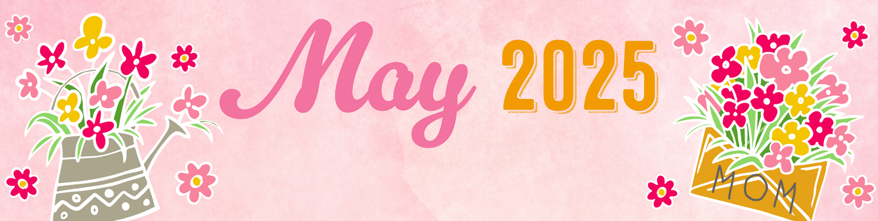
Key B B-Neighborhood, AC-Activity Center, Aud-Auditorium, H-House Activity. Activities and Locations are subject to change.

