Sunday | Monday | Tuesday | Wednesday |  | Thursday | Friday | Saturday
 |  |  |  |  | 1  May Day | 2 | 3
4 | 5  Cinco de Mayo | 6 |  | 7 | 8 | 9 | 10
11  Mother’s Day  National Skill Nursing Care Week | 12 | 13 |  | 14 | 15 | 16 | 17  Armed Forces Day
18 | 19  Victoria Day (Canada) | 20 |  | 21 | 22 | 23 | 24
25 | 26  Memorial Day | 27 |  | 28 | 29 | 30 | 31

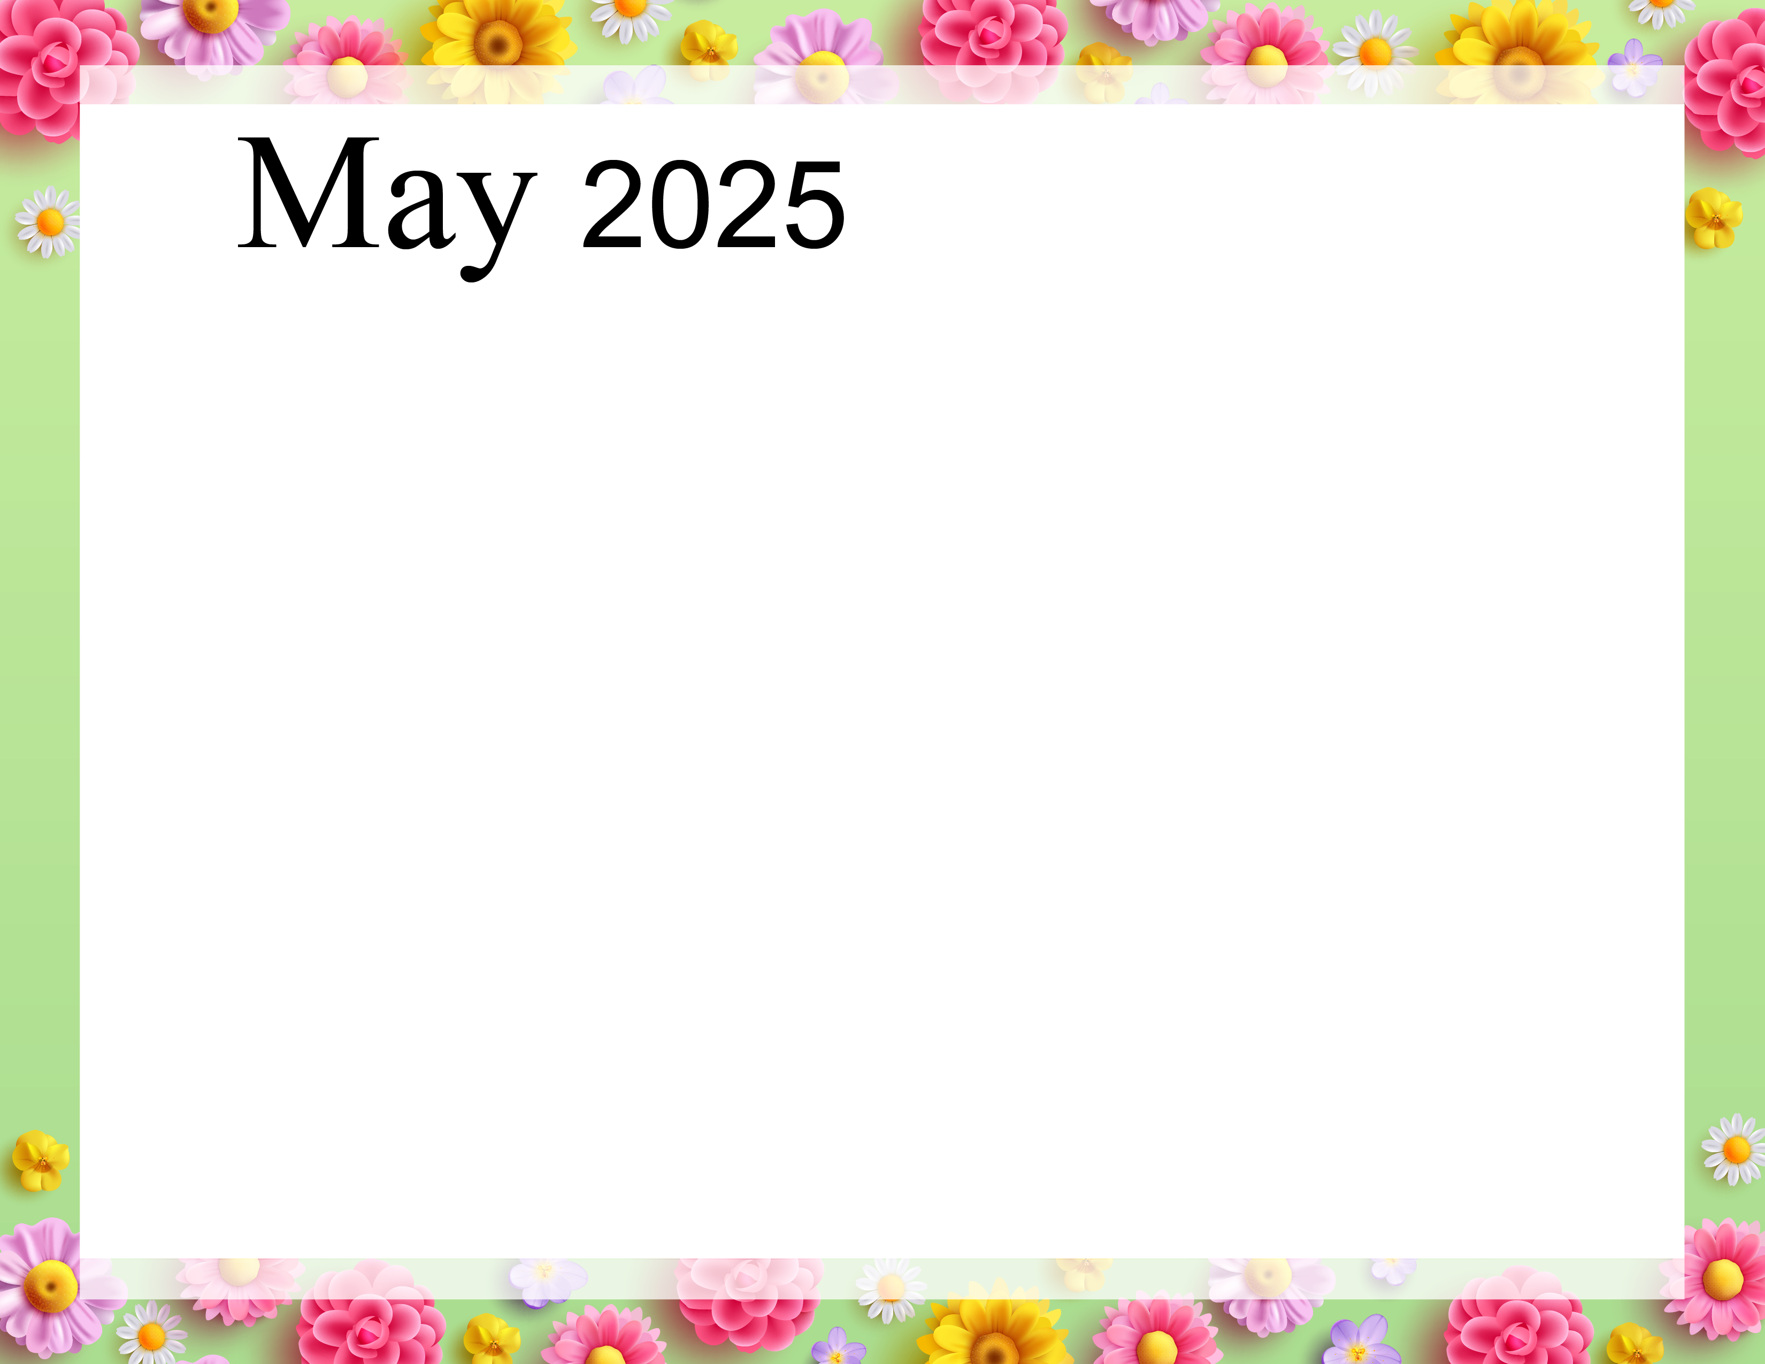  Rosewood Gardens  A & E Recreation Calendar |  |  |  | 9:40 Daily Chronicle (H)  10:15 Fun with Fitness E  10:30 Word Game E  11:15 Fun with Fitness A  11:30 Word Game A  2:00 Patio Pals (Patio)  6:30 Bingo Night (AC) | 9:40 Daily Chronicle (H)  10:00 Catholic Communion (H)  10:30 Famous Couples E  11:15 Fun with Fitness A  11:30 May IQ A  2:00 Bible Study  6:45 Happy Hour (AC) | 9:40 Daily Chronicle (H)  10:15 Fun with Fitness E  10:30 Current Events E  11:15 Fun with Fitness A  11:30 Current Events A  2:00 Bingo (Aud)
9:40 Daily Chronicle (H)  10:15 Fun with Fitness E  10:30 Trivia Treasury E  11:15 Fun with Fitness A  11:30 Trivia Treasury A  2:00 Worship (Aud) | 9:40 Daily Chronicle (H)  10:15 Fun with Fitness E  10:30 Music Trivia E  11:15 Fun with Fitness A  11:30 Music Trivia A  2:00 Crafts (AC)  6:45 Fun and Games (AC) | 9:40 Daily Chronicle (H)  10:15 Fun with Fitness E  10:30 Word Game E  11:15 Fun with Fitness A  11:30 Word Game A  2:00 Bingo (Aud)  6:30 Cup Pong (AC) | 9:40 Daily Chronicle (H)  10:15 Fun with Fitness E  10:30 Monthly Gazette E  11:15 Fun with Fitness A  11:30 Monthly Gazette A  2:00 Rosary with the  Legion of Mary (Aud)  6:45 Game Night (AC) | 9:40 Daily Chronicle (H)  10:15 Fun with Fitness E  10:30 Finish Lines E  11:15 Fun with Fitness A  11:30 Trivia A  2:00 Resident Council (Aud)  6:45 Bingo Night (AC) | 9:40 Daily Chronicle (H)  10:00 Fun with Fitness E  10:30 Famous Couples E  11:15 Fun with Fitness A  11:30 Name that Tune A  2:00 Mother’s Day Tea (Aud)  6:45 Happy Hour (AC) | 9:40 Daily Chronicle (H)  10:15 Fun with Fitness E  10:30 Current Events E  11:15 Fun with Fitness A  11:30 Current Events A  2:00 Bingo (Aud)
9:40 Daily Chronicle (H)  10:15 Fun with Fitness E  10:30 Trivia Treasury E  11:15 Fun with Fitness A  11:30 Trivia Treasury A  2:00 Worship (Aud) | 9:40 Daily Chronicle (H)  10:15 Fun with Fitness E  10:30 Music Trivia E  11:15 Fun with Fitness A  11:30 Music Trivia A  2:00 Crazy Colors Painting Flower Pots (AC)  6:45 Fun and Games (AC) | 9:40 Daily Chronicle (H)  10:15 Fun with Fitness E  10:30 Word Game E  11:15 Fun with Fitness A  11:30 Word Game A  2:00 Rock-n-Roll Bingo (Aud)  6:30 Hand Massage (AC) | 9:40 Daily Chronicle (H)  10:15 Fun with Fitness E  10:30 ABC Game E  11:15 Fun with Fitness A  11:30 Finish Lines A  2:00 Ice Cream Social (Aud) | 9:40 Daily Chronicle (H)  10:15 Fun with Fitness E  10:30 Finish Lines E  11:15 Fun with Fitness A  11:30 Trivia A  2:00 PJ’s & Black Jack with Atlantic City Dealers (Aud)  6:45 Bingo Night (AC) | 9:40 Daily Chronicle (H)  10:00 Fun with Fitness E  10:30 Famous Couples E  11:15 Fun with Fitness A  11:30 Name that Tune A  2:00 Phillies Day (Aud)  Water Ice, Soft Pretzels & Popcorn | 9:40 Daily Chronicle (H)  10:15 Fun with Fitness E  10:30 Current Events E  11:15 Fun with Fitness A  11:30 Current Events A  2:00 Bingo (Aud)
9:40 Daily Chronicle (H)  10:15 Fun with Fitness E  10:30 Trivia Treasury E  11:15 Fun with Fitness A  11:30 Trivia Treasury A  2:00 Worship (Aud) | 9:40 Daily Chronicle (H)  10:15 Fun with Fitness E  10:30 Music Trivia E  11:15 Fun with Fitness A  11:30 Music Trivia A  2:00 Crafts (AC)  6:45 Fun and Games (AC) | 9:40 Daily Chronicle (H)  10:15 Fun with Fitness E  10:30 Word Game E  11:15 Fun with Fitness A  11:30 Word Game A  2:00 Bingo (Aud)  6:30 Patio Pals (Patio) | 9:40 Daily Chronicle (H)  10:15 Fun with Fitness E  10:30 Famous Faces  11:15 Fun with Fitness A  11:30 Trivia A  2:00 Planting (Garden)  6:45 Game Night (AC) | 9:40 Daily Chronicle (H)  10:15 Fun with Fitness E  10:30 Hangman E  11:15 Fun with Fitness A  11:30 Fact or Fiction A  2:00 Patio Pals (Patio)  6:45 Game Night (AC) | 9:40 Daily Chronicle (H)  10:00 Fun with Fitness E  10:30 Word Scramble E  11:15 Fun with Fitness A  11:30 Name that Tune A  2:00 Bible Study (Aud)  6:45 Happy Hour (AC) | 9:40 Daily Chronicle (H)  10:15 Fun with Fitness E  10:30 Current Events E  11:15 Fun with Fitness A  11:30 Current Events A  2:00 Bingo (Aud)
9:40 Daily Chronicle (H)  10:15 Fun with Fitness E  10:30 Trivia Treasury E  11:15 Fun with Fitness A  11:30 Trivia Treasury A  2:00 Worship (Aud) | 9:40 Daily Chronicle (H)  10:15 Fun with Fitness E  10:30 Music Trivia E  11:15 Fun with Fitness A  11:30 Music Trivia A  2:00 Memorial Day Social (AC) | 9:40 Daily Chronicle (H)  10:15 Fun with Fitness E  10:30 Word Game E  11:15 Fun with Fitness A  11:30 Word Game A  2:00 Bingo (Aud)  6:30 Hand Massage (AC) | 9:40 Daily Chronicle (H)  10:15 Fun with Fitness E  10:30 Finish the Phrase E  11:15 Fun with Fitness A  11:30 True or False A  2:00 Birthday Party (Aud)  6:45 Game Night (AC) | 9:40 Daily Chronicle (H)  10:15 Fun with Fitness E  10:30 Word Game E  11:15 Fun with Fitness A  11:30 Hollywood Trivia A  2:00 Patio Pals (Patio)  6:45 Game Night (AC) | 9:40 Daily Chronicle (H)  10:00 Fun with Fitness E  10:30 Famous Couples E  11:15 Fun with Fitness A  11:30 Name that Tune A  2:00 Bible Study (Aud)  6:45 Happy Hour (AC) | 9:40 Daily Chronicle (H)  10:15 Fun with Fitness E  10:30 Current Events E  11:15 Fun with Fitness A  11:30 Current Events A  2:00 Bingo (Aud)
Key A A-Neighborhood, E E-Neighborhood, AC-Activity Center, Aud-Auditorium, H-House Activity. Activity and locations are subject to change.

