Sunday | Monday | Tuesday | Wednesday |  | Thursday | Friday | Saturday
 |  | 1  All Fools’ Day |  | 2 | 3 | 4 | 5
6 | 7 | 8 |  | 9 | 10 | 11 | 12  Passover Begins
13  Palm Sunday | 14 | 15 |  | 16 | 17 | 18 | 19
20  Easter Sunday | 21 | 22  Earth Day |  | 23  Administrative Professionals Day | 24 | 25  Arbor Day | 26
27 | 28 | 29 |  | 30

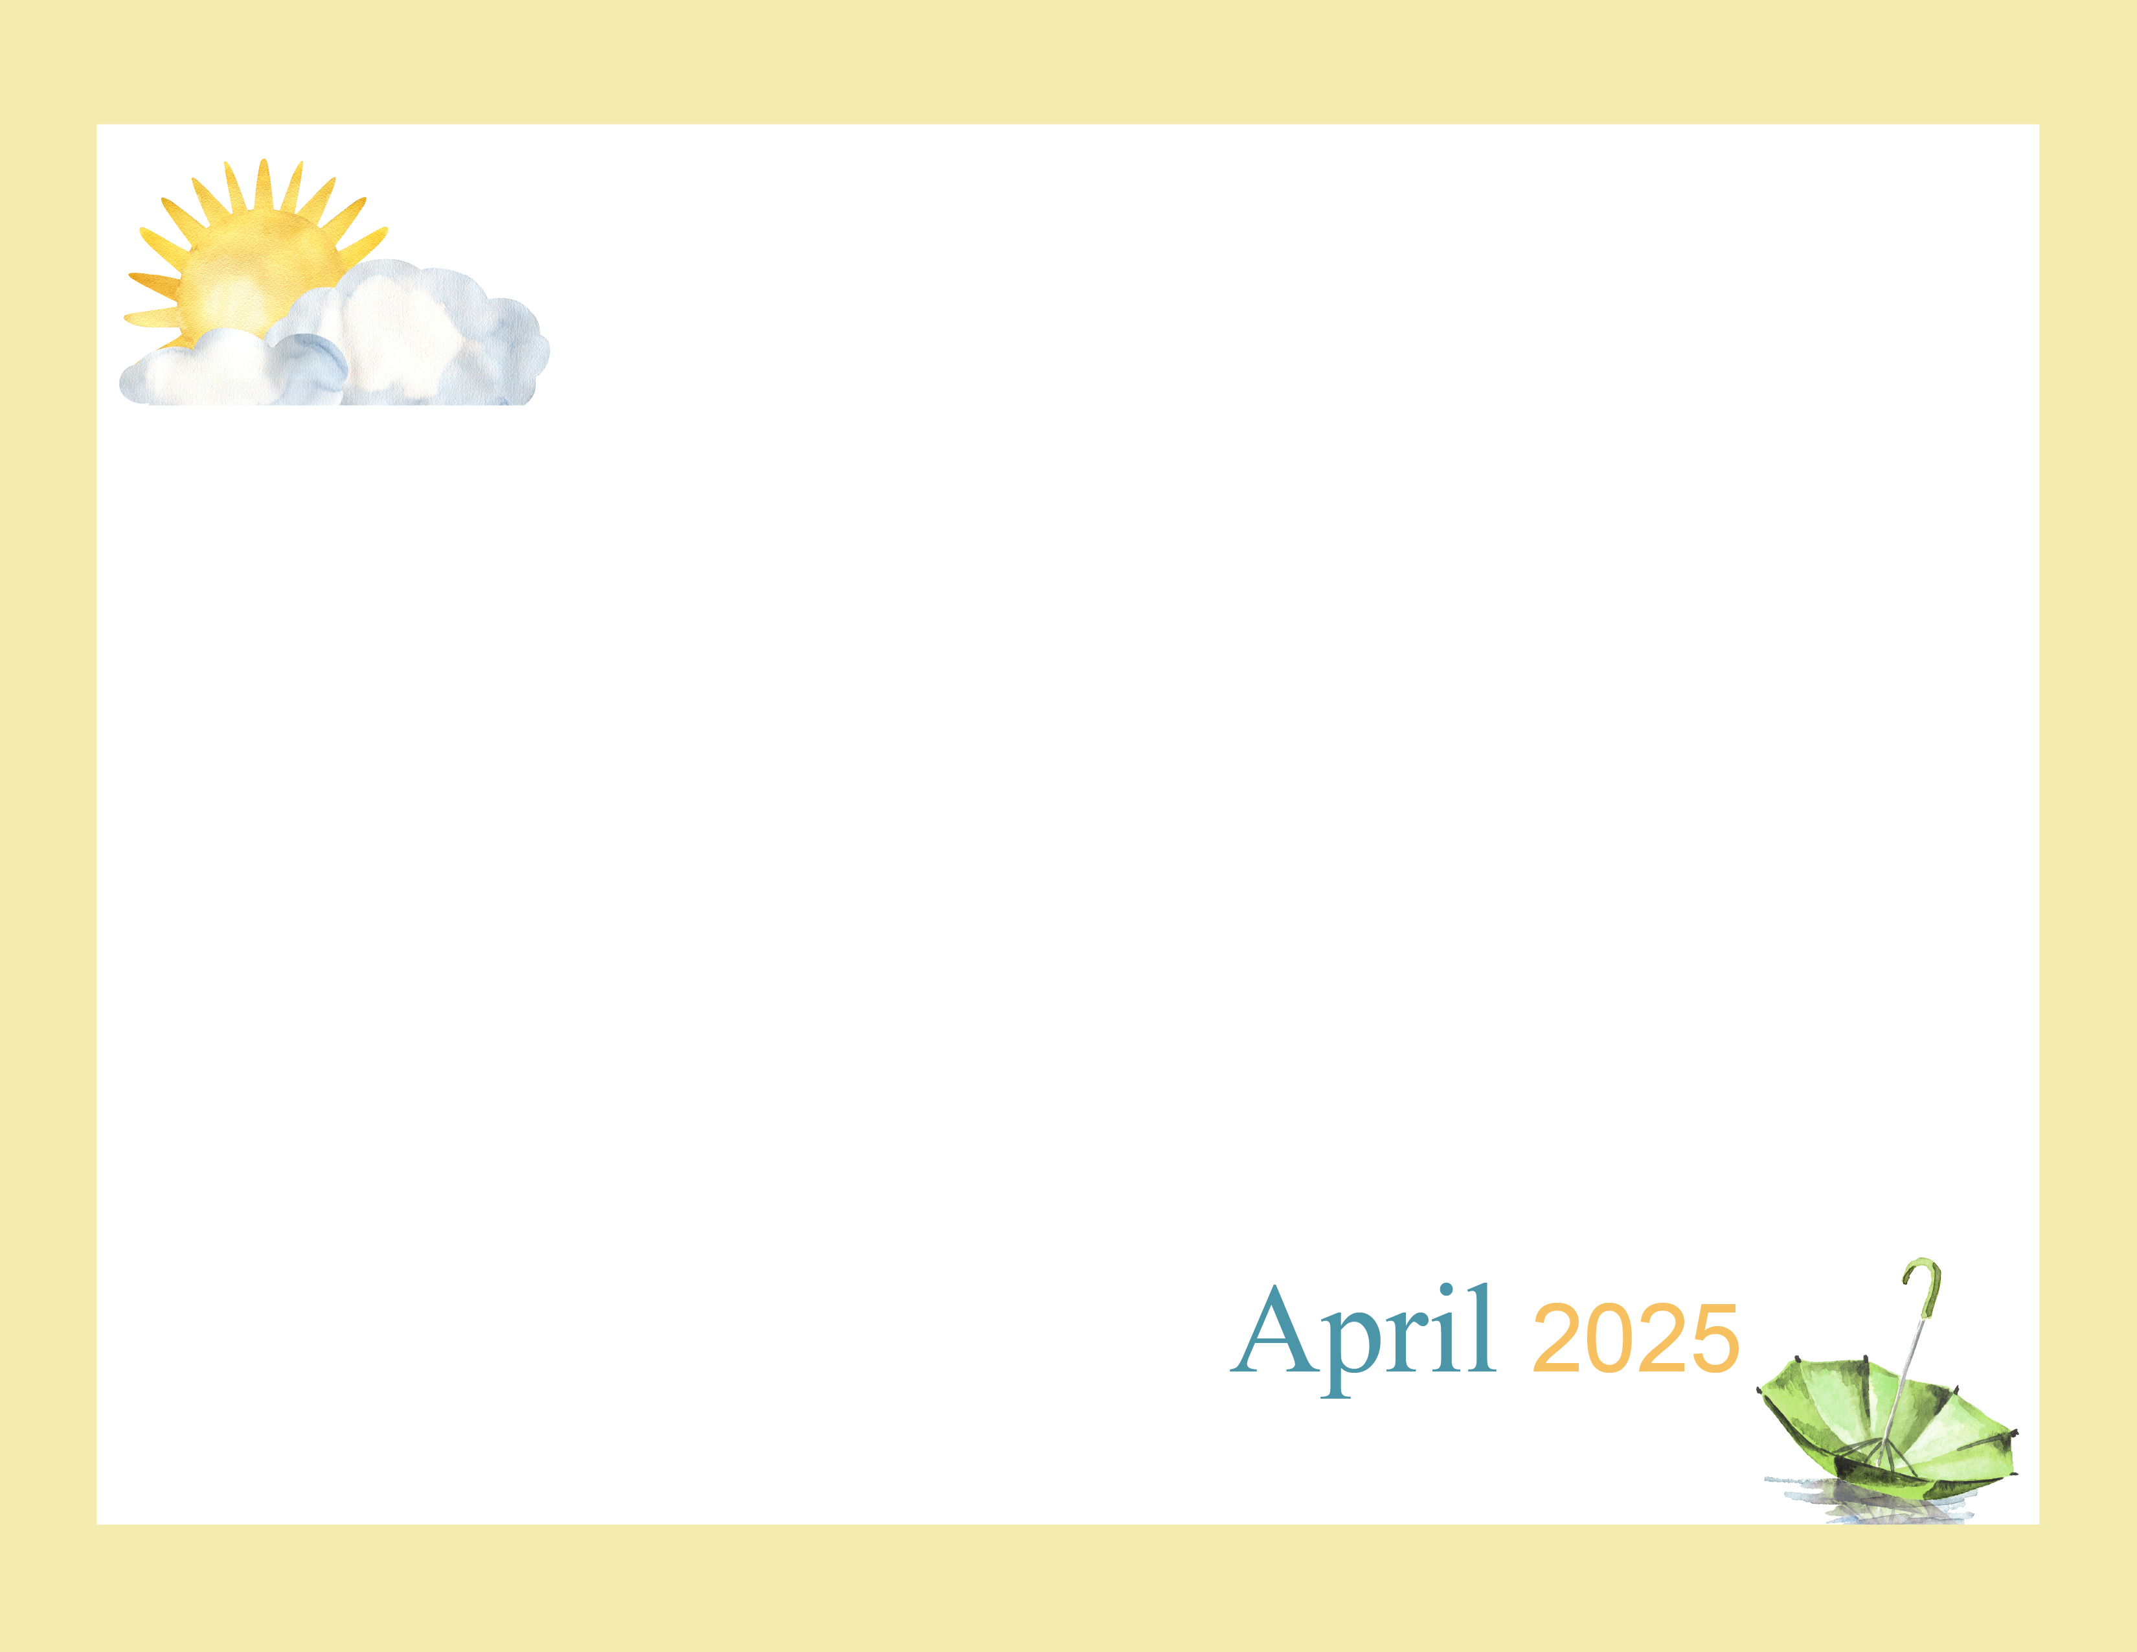  Here  comes  the  Sun! |  | 9:45 Daily Chronicles  10:15 Fun with Fitness Ch 98.4  2:00 Bingo (Aud)  6:45 Cup Pong (AC) | 9:45 Daily Chronicles  10:15 Fun with Fitness Ch 98.4  2:00 Rosary with the Legion of Mary (Aud)  6:45 Game Night (AC) | 9:45 Daily Chronicles  10:15 Fun with Fitness Ch 98.4  2:00 Bible Study (Aud)  6:45 Bingo Night (AC) | 9:45 Daily Chronicles  10:15 Fun with Fitness Ch 98.4  2:00 Independent Puzzles  6:45 Happy Hour (AC) | 9:45 Daily Chronicles  10:15 Fun with Fitness Ch 98.4  2:00 Bingo (H)  Auditorium
9:45 Daily Chronicles  10:15 Fun with Fitness Ch 98.4  2:00 Worship (H)  Auditorium | 9:45 Daily Chronicles  10:15 Fun with Fitness Ch 98.4  2:00 Crafts (AC)  6:45 Game Night (AC) | 9:45 Daily Chronicles  10:15 Fun with Fitness Ch 98.4  2:00 Bingo (Aud)  6:45 Trivia (AC) | 9:45 Daily Chronicles  10:15 Fun with Fitness Ch 98.4  2:00 Jewelry Making (AC)  6:45 Game Night (AC) | 9:45 Daily Chronicles  10:15 Fun with Fitness Ch 98.4  2:00 Bible Study (Aud)  6:45 Bingo Night (AC) | 9:45 Daily Chronicles  10:15 Fun with Fitness Ch 98.4  2:00 DJ Neil Birthday Party (Aud)  6:45 Happy Hour (AC) | 9:45 Daily Chronicles  10:15 Fun with Fitness Ch 98.4  2:00 Bingo (H)  Auditorium
9:45 Daily Chronicles  10:15 Fun with Fitness Ch 98.4  2:00 Worship (H)  Auditorium | 9:45 Daily Chronicles  10:15 Fun with Fitness Ch 98.4  2:00 Mobile Museum (Aud)  6:45 Fun & Games (AC) | 9:45 Daily Chronicles  10:15 Fun with Fitness Ch 98.4  2:00 Bingo (Aud)  6:45 Hand Massage (AC) | 9:45 Daily Chronicles  10:15 Fun with Fitness Ch 98.4  2:00 Karoke (Aud)  6:45 Game Night (AC) | 9:45 Daily Chronicles  10:15 Fun with Fitness Ch 98.4  2:00 Holy Thursday Service (Aud)  6:45 Bingo Night (AC) | 9:45 Daily Chronicles  10:15 Fun with Fitness Ch 98.4  2:00 Good Friday Service (Aud)  6:45 Happy Hour (AC) | 9:45 Daily Chronicles  10:15 Fun with Fitness Ch 98.4  2:00 Bingo (H)  Auditorium
9:45 Daily Chronicles  10:15 Fun with Fitness Ch 98.4  2:00 Worship (H)  Auditorium | 9:45 Daily Chronicles  10:15 Fun with Fitness Ch 98.4  2:00 Craft (AC)  6:45 Fun & Games (AC) | 9:45 Daily Chronicles  10:15 Fun with Fitness Ch 98.4  2:00 Bingo (Aud)  6:45 Hand Massage (AC) | 9:45 Daily Chronicles  10:15 Fun with Fitness Ch 98.4  2:00 Painting (AC)  6:45 Game Night (AC) | 9:45 Daily Chronicles  10:15 Fun with Fitness Ch 98.4  2:00 Bible Study (Aud)  6:45 Bingo Night (AC) | 9:45 Daily Chronicles  10:15 Fun with Fitness Ch 98.4  2:00 Patio Pals-Patio (weather permitting)  6:45 Happy Hour (AC) | 9:45 Daily Chronicles  10:15 Fun with Fitness Ch 98.4  2:00 Bingo (H)  Auditorium
9:45 Daily Chronicles  10:15 Fun with Fitness Ch 98.4  2:00 Worship (H)  Auditorium | 9:45 Daily Chronicles  10:15 Fun with Fitness Ch 98.4  2:00 Black Jack (AC)  6:45 Fun & Games (AC) | 9:45 Daily Chronicles  10:15 Fun with Fitness Ch 98.4  2:00 Bingo (Aud)  6:45 Jenga(AC) | 9:45 Daily Chronicles  10:15 Fun with Fitness Ch 98.4  2:00 Chef’s Corner (AC)  6:45 Game Night (AC) | Rosewood Gardens  D-Wing Recreation Calendar
Key D D-Neighborhood, AC-Activity Center, Aud-Auditorium H-House Activity. Activities and Locations are subject to change.

