Sunday | Monday | Tuesday | Wednesday |  | Thursday | Friday | Saturday
 |  | 1  All Fools’ Day |  | 2 | 3 | 4 | 5
6 | 7 | 8 |  | 9 | 10 | 11 | 12  Passover Begins
13  Palm Sunday | 14 | 15 |  | 16 | 17 | 18 | 19
20  Easter Sunday | 21 | 22  Earth Day |  | 23  Administrative Professionals Day | 24 | 25  Arbor Day | 26
27 | 28 | 29 |  | 30

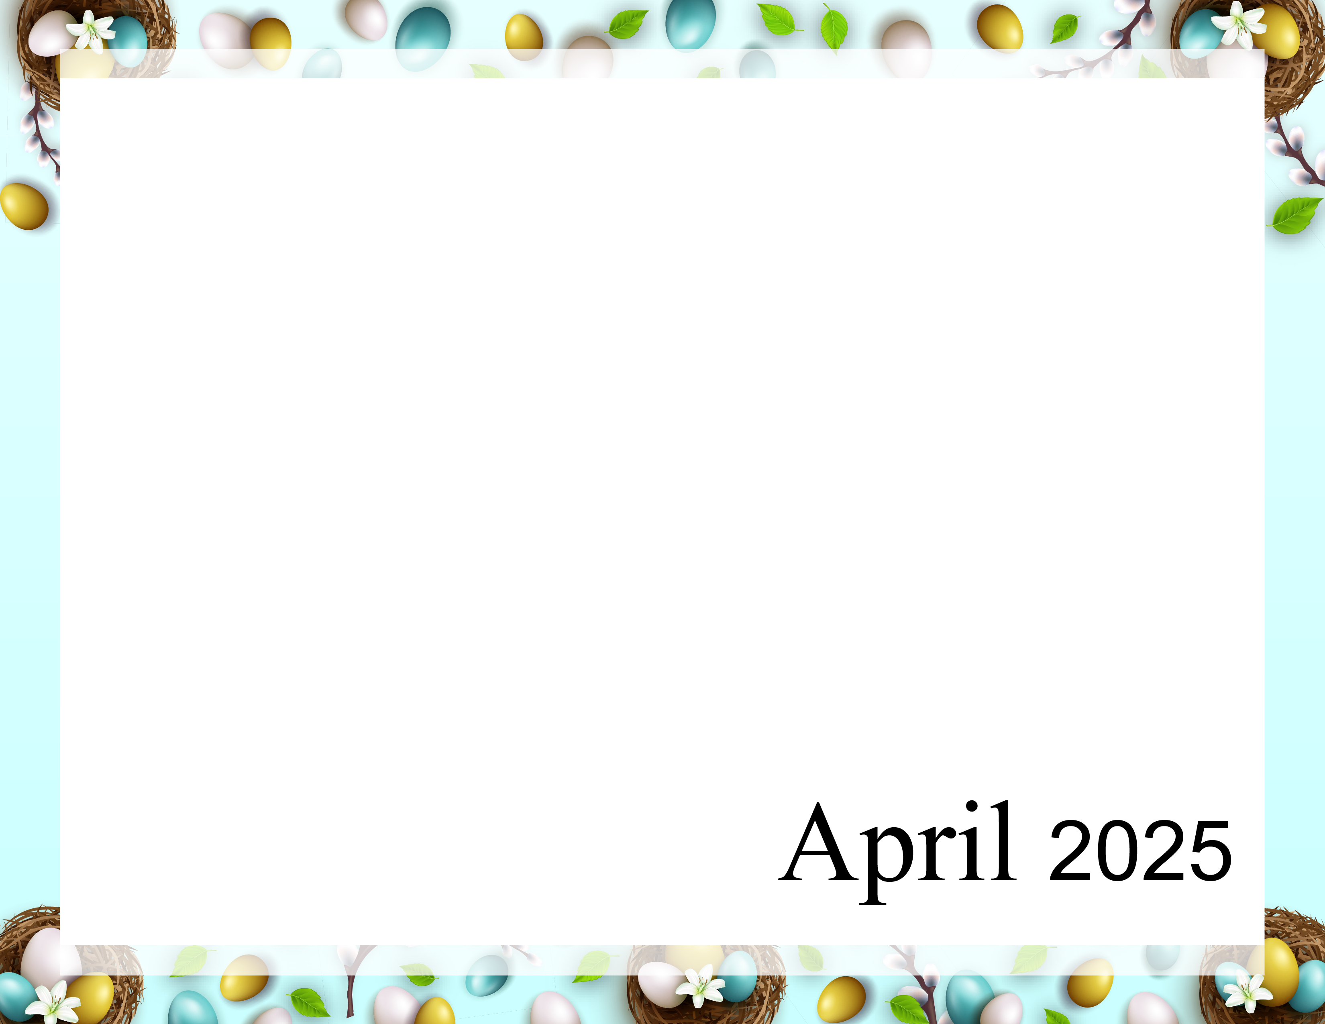  April Showers bring May Flowers |  | 9:40 Daily Chronicle (H)  10:15 Fun with Fitness E  10:30 Word Game E  11:15 Fun with Fitness A  11:30 Word Game A  2:00 Bingo (Aud)  6:30 Cup Pong (AC) | 9:40 Daily Chronicle (H)  10:15 Fun with Fitness E  10:30 Monthly Gazette E  11:15 Fun with Fitness A  11:30 Monthly Gazette A  2:00 Rosary with the  Legion of Mary (Aud)  6:45 Game Night (AC) | 9:40 Daily Chronicle (H)  10:15 Fun with Fitness E  10:30 Famous Couples E  11:15 Fun with Fitness A  11:30 April IQ A  2:00 Bible Study  6:45 Bingo Night (AC) | 9:40 Daily Chronicle (H)  10:00 Communion (H)  10:30 Famous Faces E  11:15 Fun with Fitness A  11:30 Name that Tune (A)  2:00 Resident Council (Aud)  6:45 Happy Hour (AC) | 9:40 Daily Chronicle (H)  10:15 Fun with Fitness E  10:30 Current Events E  11:15 Fun with Fitness A  11:30 Current Events A  2:00 Bingo (Aud)
9:40 Daily Chronicle (H)  10:15 Fun with Fitness E  10:30 Trivia Treasury E  11:15 Fun with Fitness A  11:30 Trivia Treasury A  2:00 Worship (Aud) | 9:40 Daily Chronicle (H)  10:15 Fun with Fitness E  10:30 Music Trivia E  11:15 Fun with Fitness A  11:30 Music Trivia A  2:00 Crafts (AC)  6:45 Fun and Games (AC) | 9:40 Daily Chronicle (H)  10:15 Fun with Fitness E  10:30 Word Game E  11:15 Fun with Fitness A  11:30 Word Game A  2:00 Bingo (Aud)  6:30 Trivia (AC) | 9:40 Daily Chronicle (H)  10:15 Fun with Fitness E  10:30 ABC Game E  11:15 Fun with Fitness A  11:30 True or False A  2:00 Jewelry Making (AC)  6:45 Game Night (AC) | 9:40 Daily Chronicle (H)  10:15 Fun with Fitness E  10:30 Finish Lines E  11:15 Fun with Fitness A  11:30 Trivia A  2:00 Bible Study (Aud)  6:45 Bingo Night (AC) | 9:40 Daily Chronicle (H)  10:15 Fun with Fitness  10:30 Famous Faces E  11:15 Fun with Fitness A  11:30 Name that Tune (A)  2:00 DJ Neil Birthday Party  (Aud)  6:45 Happy Hour (AC) | 9:40 Daily Chronicle (H)  10:15 Fun with Fitness E  10:30 Current Events E  11:15 Fun with Fitness A  11:30 Current Events A  2:00 Bingo (Aud)
9:40 Daily Chronicle (H)  10:15 Fun with Fitness E  10:30 Trivia Treasury E  11:15 Fun with Fitness A  11:30 Trivia Treasury A  2:00 Worship (Aud) | 9:40 Daily Chronicle (H)  10:15 Fun with Fitness E  10:30 Music Trivia E  11:15 Fun with Fitness A  11:30 Music Trivia A  2:00 Mobile Museum (Aud)  6:45 Fun and Games (AC) | 9:40 Daily Chronicle (H)  10:15 Fun with Fitness E  10:30 Pong Toss E  11:15 Fun with Fitness A  11:30 Word Game A  2:00 Bingo (Aud)  6:30 Hand massage (AC) | 9:40 Daily Chronicle (H)  10:15 Fun with Fitness E  10:30 Word Game E  11:15 Fun with Fitness A  11:30 Fact or Fiction A  2:00 Karaoke (Aud)  6:45 Game Night (AC) | 9:40 Daily Chronicle (H)  10:15 Fun with Fitness E  10:30 Finish Lines E  11:15 Fun with Fitness A  11:30 Trivia A  2:00 Holy Thursday Service (Aud)  6:45 Bingo Night (AC) | 9:40 Daily Chronicle (H)  10:15 Fun with Fitness (E)  10:30 Name that Tune E  11:15 Fun with Fitness A  11:30 Name that Tune (A)  2:00 Good Friday Service (Aud)  6:45 Happy Hour (AC) | 9:40 Daily Chronicle (H)  10:15 Fun with Fitness E  10:30 Current Events E  11:15 Fun with Fitness A  11:30 Current Events A  2:00 Bingo (Aud)
9:40 Daily Chronicle (H)  10:15 Fun with Fitness E  10:30 Trivia Treasury E  11:15 Fun with Fitness A  11:30 Trivia Treasury A  2:00 Worship (Aud) | 9:40 Daily Chronicle (H)  10:15 Fun with Fitness E  10:30 Music Trivia E  11:15 Fun with Fitness A  11:30 Music Trivia A  2:00 Crafts (AC)  6:45 Fun and Games (AC) | 9:40 Daily Chronicle (H)  10:15 Fun with Fitness E  10:30 Hangman E  11:15 Fun with Fitness A  11:30 Word Game A  2:00 Bingo (Aud)  6:30 Hand Massage (AC) | 9:40 Daily Chronicle (H)  10:15 Fun with Fitness E  10:30 Word Game E  11:15 Fun with Fitness A  11:30 True or False A  2:00 Painting (AC)  6:45 Game Night (AC) | 9:40 Daily Chronicle (H)  10:15 Fun with Fitness E  10:30 Finish the Phrase E  11:15 Fun with Fitness A  11:30 Jeopardy A  2:00 Bible Study (Aud)  6:45 Bingo Night (AC) | 9:40 Daily Chronicle (H)  10:15 Fun with Fitness (E)  10:30 Name that Tune E  11:15 Fun with Fitness A  11:30 Name that Tune (A)  2:00 Patio Pals – Patio  (weather permitting)  6:45 Happy Hour (AC) | 9:40 Daily Chronicle (H)  10:15 Fun with Fitness E  10:30 Current Events E  11:15 Fun with Fitness A  11:30 Current Events A  2:00 Bingo (Aud)
9:40 Daily Chronicle (H)  10:15 Fun with Fitness E  10:30 Trivia Treasury E  11:15 Fun with Fitness A  11:30 Trivia Treasury A  2:00 Worship (Aud) | 9:40 Daily Chronicle (H)  10:15 Fun with Fitness E  10:30 Music Trivia E  11:15 Fun with Fitness A  11:30 Music Trivia A  2:00 Black Jack (AC)  6:45 Fun and Games (AC) | 9:40 Daily Chronicle (H)  10:15 Fun with Fitness E  10:30 Word Game E  11:15 Fun with Fitness A  11:30 Word Game A  2:00 Bingo (Aud)  6:30 Jenga (AC) | 9:40 Daily Chronicle (H)  10:15 Fun with Fitness E  10:30 Word Game E  11:15 Fun with Fitness A  11:30 Fact or Fiction A  2:00 Chef’s Corner (AC)  6:45 Game Night (AC) | Rosewood Gardens  A & E Recreation Calendar
Key A A-Neighborhood E E-Neighborhood, AC-Activity Center, Aud-Auditorium, H-House Activity. Activity and locations are subject to change.

